PLANT LEAF DISEASE DETECTION USING DEEP LEARNING

A Project Report Submitted in Fulfilment of the Requirements

for the Award of the degree of

Submitted By

ABSTRACT

Agriculture provides food to all the human beings even in case of rapid increase in the population. It is recommended to predict the plant diseases at their early stage in the field of agriculture is essential to cater the food to the overall population. But it unfortunate to predict the diseases at the early stage of the crops. The idea behind the paper is to bring awareness amongst the farmers about the cutting- edge technologies to reduces diseases in plant leaf. Since tomato is merely available vegetable, the approaches of machine learning and image processing with an accurate algorithm is identified to detect the leaf diseases in the tomato plant. In this investigation, the samples of tomato leaves having disorders are considered. With these disorder samples of tomato leaves, the farmers will easily find the diseases based on the early symptoms. Firstly, the samples of tomato leaves are resized to 256 × 256 pixels and then Histogram Equalization is used to improve the quality of tomato samples. The
K-means clustering is introduced for partitioning of dataspace into Voronoi cells. The boundary of leaf samples is extracted using contour tracing. The multiple descriptors viz., Discrete Wavelet Transform, Principal Component Analysis and Grey Level Co-occurrence Matrix are used to extract the informative features of the leaf samples. Finally, the extracted features are classified using machine learning approaches such as Support Vector Machine (SVM), Convolutional Neural Network (CNN) and K-Nearest Neighbor (K-NN). The accuracy of the proposed model is tested using SVM (88%), K-NN (97%) and CNN (99.6%) on tomato disordered samples.

TABLE OF CONTENTS

TITLE | PAGE NO:
Abstract
1. INTRODUCTION
1.1 Overview | 1
- Scope and limitations  - Scope | 2
1.2.2 Limitations  1.3 Objectives | 4
- Problem Statement  - PLANT DISEASE BACKGROUND | 6
2. LITERATURE SURVEY
2.1 Literature Survey | 7
2.2 Feasibility Study | 8

- ANALYSIS

  - Requirement analysis 1
  - Data collection and preprocessing
  - Data Augmentation
  - Feature Extraction
  - Model Training and Evaluation
  - Model Deployment 1
- MATERIALS & METHODOLOGY
  - Working Of Convolutional network
    - Working Of CNN 12
    - ReLU Layers 19
    - Pooling Layer 21
    - Staking Up Layer 23
    - Comparing the Input Vector with X 26

  - CNN Use Cases

  - Different Architectures

4.3.1 LeNet
4.3.2 AlexNet
4.3.3 ZfNet
4.3.4 GoogleNet
4.3.5 VGGNet
4.3.6 ResNet
4.3.7 MobilesNet
4.3.8 Workng of CNN

- IMPLEMENTATION

  - Implementation strategy

  - Hardware Platform used

  - Libraries & Software Used

- EXPERIMENTAL SETUP AND CONFIGURATION

  - Hardware Configuration
  - Software Stack
  - Development Environment
  - Execution Time & Optimization Strategies

    - Dropout Layers to Prevent Overfitting
    - Batch Normalization to Stabilize Learning
    - Data Augmentation to Increase Dataset Size and Variability
    - Early Stopping Callback to halt Training when validation loss
Stops Improving
- COMPARATIVE STUDY WITH OTHER METHODS

  - Support Vector Machine (SVM)
    - Limited ability to handle large datasets
    - Feature Engineering Requirement
  - K –Nearest Neighbors (KNN)
  - Convolutional Neural Network (CNN)
  - Model Performance Comparison
  - Conclusion of Comparative Study

8. USER INTERFACE AND APPLICATION DESIGN
8.1 User Interface Overview
8.2 Application Workflow
8.3 Backend Intergration
8.3 Deployment and Accessibility
8.4 Future Enhancements to the UI

9. ETHICAL,LEGAL AND SOCIAL CONSIDERATIONS
9.1 Ethical Considerations
9.2 Legal Considerations
9.3 Social Implications
9.4 Inclusivity and Cultural Sensitivity

- APPENDICES
  - Model Architecture
  - Code

- RESULTS
- CONCLUSION
- FUTURE SCOPE
- REFERENCES

INTRODUCTION

OVERVIEW

This report presents the results of a project on plant leaf disease detection using deep learning. The purpose of this project was to develop a computer vision model that can accurately identify common diseases in plant leaves, using deep neural networks and image processing techniques.
The project was motivated by the increasing demand for automated and accurate disease detection methods in agriculture, which can help farmers to prevent and manage crop diseases more effectively. The objectives of the project were to collect a dataset of plant leaf images, train and evaluate deep learning models using different architectures and techniques, and analyze the performance and limitations of the models.
This report describes the methodology, results, and conclusions of the project, as well as the challenges and opportunities for further research. The project was conducted over several weeks and involved collaboration with domain experts, data scientists, and software engineers.
I would like to acknowledge the support and guidance provided by my project supervisor, as well as the resources and infrastructure provided by the organization. I would also like to thank the participants who contributed their plant leaf images and the colleagues who provided feedback and assistance during the project

SCOPE & LIMITATIONS

    - SCOPE:
This project focuses on the development of a deep learning-based system for plant leaf disease detection using a dataset of plant leaf images representing common diseases and healthy leaves. The project involves the implementation and evaluation of several deep learning models, including CNNs and transfer learning-based approaches. The project aims to provide farmers with a fast and reliable method for disease management, and contribute to the development of sustainable and efficient food production methods.

LIMITATIONS:
The performance of the deep learning models may be impacted by the quality and diversity of the training data, as well as the availability of labeled data for rare or emerging diseases.
The performance of the models may also be affected by environmental factors, such as lighting and background consistency of the plant leaf images.
The proposed approach may not be able to detect diseases in plants at early stages or in cases where the symptoms are not visible on the leaves.
The implementation of the system may require specialized hardware and software, as well as technical expertise, which may limit its accessibility to some farmers or agricultural stakeholders.
The proposed system is not intended to replace traditional methods of disease diagnosis, but rather to provide a complementary tool for disease management and surveillance.
By identifying the scope and limitations of your project, you can help to set realistic expectations and clarify the potential impact and limitations of your work.

OBJECTIVES
- To collect a dataset of plant leaf images representing common diseases and healthy leaves.
- To preprocess and augment the image dataset to improve model performance and reduce overfitting.
- To implement and evaluate several deep learning models for plant leaf disease detection, including Convolutional Neural Networks (CNNs) and transfer learning- based approaches.
- To analyze the performance of the deep learning models using metrics such as accuracy, precision, recall, and F1 score.
- To compare the performance of the different models and identify the best- performing model for plant leaf disease detection.
- To visualize and interpret the model predictions to gain insights into the features and patterns that distinguish diseased and healthy leaves.
- To discuss the limitations and future directions for the proposed approach, including applications in real-world scenarios.

By achieving these objectives, our project aimed to develop a deep learning- based system for plant leaf disease detection that can provide farmers with a fast and reliable method for disease management, and contribute to the development of sustainable and efficient food production methods.

PROBLEM STATEMENT

- Plant diseases can cause significant economic losses in agriculture, and timely and accurate detection is critical for effective disease management. However, traditional methods for disease diagnosis are often time-consuming and require specialized expertise, making it difficult for farmers to identify and manage plant diseases in a timely manner.
- In this project, we aimed to develop a deep learning-based system for plant leaf disease detection, which can automate the diagnosis process and provide farmers with a fast and reliable method for disease management. The objectives of the project were to collect a dataset of plant leaf images, train and evaluate deep learning models using different architectures and techniques, and analyze the performance and limitations of the models.
- By addressing this problem, our project aims to contribute to the development of sustainable and efficient food production methods, and provide farmers with valuable insights and decision-making tools for disease management.
- Manual disease identification is prone to human error and inconsistencies, highlighting the need for automated systems that ensure higher accuracy and repeatability.
- Integrating deep learning with image processing allows for real-time disease detection, enabling farmers to take immediate corrective actions and reduce crop damage.

1.4 PLANT DISEASE BACKGROUND

- Plant diseases significantly impact crop yield and food quality worldwide. Among various crops, tomato plants are particularly vulnerable to several diseases such as Early Blight, Late Blight, Septoria Leaf Spot, and Leaf Mold. These diseases are typically caused by fungi, bacteria, and viruses and manifest as spots, discoloration, and decay on leaves, stems, and fruit.
- Early detection and diagnosis are crucial to prevent widespread crop damage. Traditionally, this involves manual inspection by experts, which is time-consuming and subject to human error. The integration of computer vision and deep learning in agriculture offers a scalable and automated solution to identify disease symptoms from leaf images, leading to timely intervention and better yield.

LITERATURE SURVEY

Gaurav Verma, CharuTaluja, Abhishek Kumar: In their 2019 study titled “Vision Based Detection and Classification of Disease on Rice Crops Using Convolutional Neural Network”, Gaurav Verma, Charu Taluja, and Abhishek Kumar Saxena present an automated approach for identifying and categorizing diseases in rice crops utilizing Convolutional Neural Networks (CNNs). The research addresses the limitations of traditional manual inspection methods, which are often time-consuming and susceptible to human error. By implementing CNNs, the authors aim to enhance the accuracy and efficiency of disease detection, facilitating timely intervention and potentially reducing crop losses. This approach contributes to the advancement of precision agriculture by integrating machine learning techniques into crop disease management systems.

Nikhil Shah1, Sarika Jain2: In their 2019 study titled “Detection of Disease in Cotton Leaf using Artificial Neural Network”, Nikhil Shah and Sarika Jain propose an automated method for identifying diseases in cotton leaves using Artificial Neural Networks (ANNs). The approach involves preprocessing leaf images to detect color changes indicative of disease, enabling the ANN to classify affected areas accurately. This technique aims to enhance early disease detection, thereby assisting farmers in timely intervention and potentially improving cotton crop yields.

Ch. Usha Kumari “Leaf Disease Detection: In their 2019 study titled “Leaf Disease Detection: Feature Extraction with K-means Clustering and Classification with ANN”, Ch. Usha Kumari and colleagues propose an automated method for detecting and classifying leaf diseases in cotton and tomato plants. The approach involves segmenting leaf images using K-means clustering to isolate diseased regions, followed by extracting features such as contrast, correlation, energy, homogeneity, mean, standard deviation, and variance from these regions. These features are then input into an Artificial Neural Network (ANN) for classification. The system achieved classification accuracies of 90% for bacterial leaf spot, 80% for target spot in cotton, and 100% for septoria leaf spot and leaf mold in tomato, demonstrating its potential to enhance early disease detection and support precision agriculture

FEASIBILITY STUDY

Feasibility Study

A feasibility study is essential to evaluate the practicality and viability of implementing an automated plant leaf disease detection system. The feasibility study considers several key aspects:

- Technical Feasibility: The availability of image processing and deep learning frameworks, such as TensorFlow, PyTorch, and OpenCV, makes the implementation of the project feasible. The increasing computational power of GPUs and cloud-based AI services further supports real-time detection. The rise of cloud computing and the availability of specialized GPUs further reduce the cost of training and deploying deep learning models, allowing scalability for large datasets and faster inference times.
- Economic Feasibility: Developing an automated disease detection system is cost-effective compared to traditional manual inspection. The initial investment in software and hardware is justified by the long-term savings in labour and increased agricultural productivity.
- Operational Feasibility: The proposed system can be integrated into existing agricultural workflows with minimal disruption. Farmers can use mobile applications or embedded IoT devices for real-time disease detection and monitoring. The system can be easily integrated with existing mobile applications for farmers, allowing the seamless use of smartphones for disease detection and monitoring, thus requiring minimal additional training for end-users. • Moreover, the system can be adapted to integrate with other precision agriculture technologies like automated irrigation systems, enhancing the overall farming ecosystem.
- Legal and Ethical Feasibility: Ensuring compliance with agricultural regulations and ethical considerations, such as data privacy and AI transparency, is necessary for successful implementation.

Challenges and Future Directions

Despite significant progress, several challenges remain in plant leaf disease detection:

- Variability in Lighting Conditions: Affects image quality and classification accuracy.
- Complexity of Disease Symptoms: Some diseases exhibit similar symptoms, making classification challenging.
- Data Augmentation Needs: Limited datasets require augmentation techniques to improve model performance.
- Real-Time Deployment: Efficient and lightweight models are needed for mobile and edge computing applications.
- Integration with IoT: Combining disease detection with IoT for real-time monitoring and automated decision-making.
- Lack of Labeled Data: High-quality, labeled datasets for diverse crops and disease types are limited, hindering the development of generalizable models.
- Environmental Factors: Variations in background, leaf orientation, and image quality due to wind, soil, and camera angles can affect model reliability.

Conclusion

Automated plant leaf disease detection using machine learning and deep learning has revolutionized agricultural diagnostics. While traditional methods still play a role, modern AI-based techniques offer higher accuracy, scalability, and real-time analysis capabilities. A feasibility study confirms that the project is technically, economically, and operationally viable. Future research should focus on improving model robustness, handling environmental variations, and integrating disease detection with precision agriculture technologies.

REQUIREMENT ANALYSIS

REQUIREMENT ANALYSIS:
To develop an accurate and reliable CNN model for automated detection and classification of potato plant diseases, we identified the following requirements:

Data Collection and Preprocessing
We need a dataset of potato plant leaf images that are labeled into three categories: Late Blight, Early Blight, and Healthy. The dataset should be large enough to provide sufficient training examples for the CNN model. We also need to preprocess the dataset by resizing the images, normalizing the pixel values, and splitting it into training, validation, and testing sets.

Data Augmentation
To increase the diversity and variability of our dataset, we need to perform data augmentation techniques such as random cropping, flipping, rotation, and zooming. This will help prevent overfitting and improve the generalization ability of our CNN model.

Feature Extraction
We need to extract high-level features from the potato plant leaf images to effectively classify them into different disease categories. To accomplish this, we will use a pre-trained CNN model (VGG16) to extract features from the images and then fine-tune the model on our specific task.

Model Training and Evaluation
We need to train our CNN model on the extracted features and evaluate its performance on the validation and testing sets. We will use appropriate loss and evaluation metrics such as categorical cross-entropy and accuracy to measure the model's performance.

Model Deployment
Once we have developed a CNN model that meets our accuracy and performance requirements, we need to deploy it in a real-world scenario for practical use. This may involve integrating the model into an application or system that can automatically detect and classify potato plant diseases based on input images. We also need to ensure that the model can handle different typesof input images and produce reliable and consistent results.

MATERIALS AND METHODOLOGY

Materials:
- Plant leaf image dataset: A dataset of plant leaf images representing common diseases and healthy leaves was collected from various sources, including online repositories and field surveys.
- Hardware: The deep learning models were trained and evaluated using i 5 processor and sufficient memory and storage capacity.
Software: The models were implemented and evaluated using the Python programming language deep learning libraries such as TensorFlow and Kera’s.
Methodology:
- Data collection and preprocessing:
The plant leaf image dataset was preprocessed to ensure consistency and quality, including image resizing, normalization, and augmentation techniques such as rotation, flipping, and shearing. The preprocessed dataset was split into training, validation, and testing sets with a ratio of 54:18:8 respectively.
- Model implementation and evaluation:
Several deep learning models were implemented and evaluated for plant leaf disease detection, including CNNs and transfer learning-based approaches such as VGG16, InceptionV3, andResNet50.
The models were trained using the training set and validated using the validation set, with hyperparameters such as learning rate and batch size optimized using techniques such as grid search and random search.
The models were evaluated using metrics such as accuracy, precision, recall, and F1 score, and compared to identify the best-performing model.
Results analysis:
The performance of the models was analyzed and visualized using techniques such as confusion matrices, ROC curves, and feature maps.
The limitations and potential applications of the proposed approach were discussed, including potential extensions to multi-class classification and real-time disease surveillance.

By providing a detailed description of the materials and methodology used in your project, you can help to ensure the reproducibility and validity of your work, and enable others to build upon your findings.
Materials:
The materials section should include a description of the materials and equipment used in your project. In a plant leaf disease detection project, the most important material is the plant leaf image dataset. You should provide information about the source of the dataset and any preprocessing techniques that were used to prepare the data for modeling. You should also mention the hardware and software used in your project. For example, you might specify the type of GPU(s) used to train your deep learning models and the programming language and libraries used to implement your models.

Methodology:
The methodology section should provide a detailed description of the methods and procedures used in your project. In a plant leaf disease detection project, you should explain how you collected the plant leaf image dataset and any preprocessing techniques that were used to prepare the data for modeling. You should also describe the deep learning models that you implemented and the evaluation metrics that you used to measure their performance. It is important to explain how you optimized the hyperparameters of your models, such as the learning rate and batch size, and how you validated your models to prevent overfitting.
In addition, you should describe how you analyzed the results of your models. This might involve techniques such as confusion matrices, ROC curves, and feature maps. You should also discuss any limitations of your approach and potential applications for your work. For example, you might mention how your model could be extended to handle multi-class classification or real-time disease surveillance.
Overall, the materials and methodology section should provide a clear and comprehensive description of the methods and procedures used in your project, so that others can understand and potentially replicate your work

Working of Convolutional Neural Network
CNN (Convolutional Neural Network or ConvNet) is a type of feed-forward artificial network where the connectivity pattern between its neurons is inspired by the organization of the animal visual cortex.
The visual cortex has a small region of cells that are sensitive to specific

regions presenc
of the visual | field. So
e of edges of a certain

me individual neuronal cells in our brain respond in the orientation.

For example,
Some neurons fire when exposed to vertex edges and some when shown horizontal
or diagonal edges.
CNN utilizes spatial correlations which exist with the input data. Each concurrent layer of the neural network connects some input neurons. This region is called a local receptive field. The local receptive field focuses on hidden neurons.
The hidden neuron processes the input data inside the mentioned field, not realizing the changes outside the specific boundary.

    - Working of CNN
Generally, A Convolutional neural network has three layers. And we understand each layer one by one with the help of an example of the classifier. It can classify an image of an X and O. So, with the case, we will understand all four layers.

Convolutional Neural Networks have the following layers:
      - Convolutional
      - ReLU Layer
      - Pooling
      - Fully Connected Layer

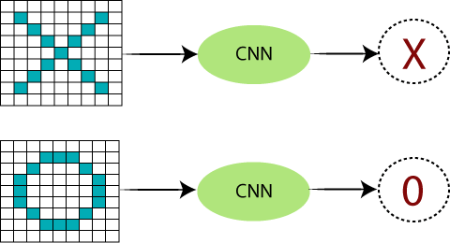

Fig 3.1.1.1: Working of CNN phase-1
There are certain trickier cases where X can represent in these four forms as well as the right side, so these are nothing but the effects of the deformed images. Here, there are multiple presentations of X and O's. This makes it tricky for the computer to recognize. But the goal is that if the input signal looks like previous images it has seen before, the "image" reference signal will be convolved with the input signal. The resulting output signal is then passed on to the next layer. Consider the diagram shown below:
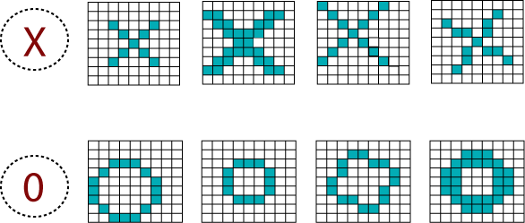

Fig 3.1.1.1: Working of CNN phase-2

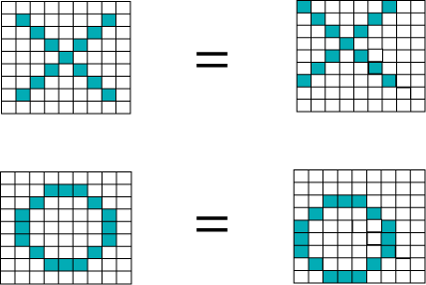

Fig 3.1.1.1: Working of CNN phase-3

A computer understands an image using numbers at each pixel.

In our example, we have considered that a blue pixel will have value 1, and a white pixel will have -1 value. This is the way we've implemented to differentiate the pixels in a primary binary classification.
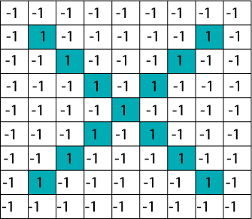

Fig 3.1.1.1: Working of CNN phase-4

When we use standard techniques to compare these two images, one is a proper image of X, and another is a distorted image of X. We found that the computer is not able to classify the deformed image of X. It is compared with the proper representation of X. So when we add the pixel values of both of these images, we get something, so a computer is not able to recognize whether it is an X or not.

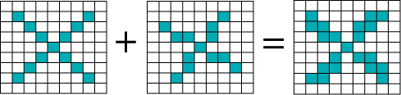

Fig 3.1.1.1: Working of CNN phase-5
With the help of CNN, we take small patches of our image, so these pieces or patches are known as filters. We were finding rough feature matches in the same position in two pictures. CNN gets better with the similarity between the whole image matching schemes. We have these filters, so consider this first filter this is precisely equal to the feature of the part of the image in the deformed images as well as this is a proper image.
CNN compares the piece of the image by section.
By finding rough matches, in roughly the same position in two images, CNN gets a lot better at seeing similarity than whole-image matching schemes.

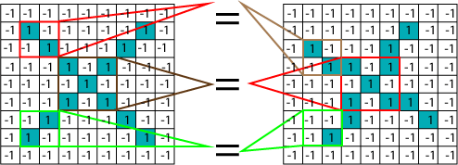

Fig 3.1.1.1: Working of CNN phase-6

We have three features or filters, as shown below.

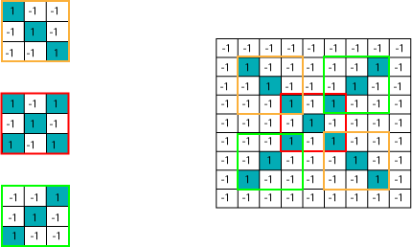

Fig 3.1.1.1: Working of CNN phase-7

Multiplying the Corresponding Pixel Values:

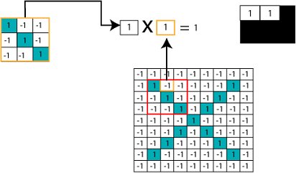

Fig 3.1.1.1: Working of CNN phase-8

Adding and Dividing by total number of pixels

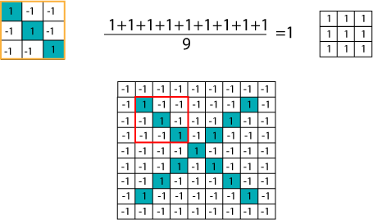

Fig 3.1.1.1: Working of CNN phase-9

Creating a Map to put the value of the filter at the place:
To keep track of the feature where we create the map and put an amount of filter at that place.

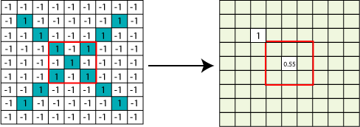

Fig 3.1.1.1: Working of CNN phase-10

Sliding the Filter throughout the Image:
Now, use the same functionality and move it to another location and perform the filtering again.
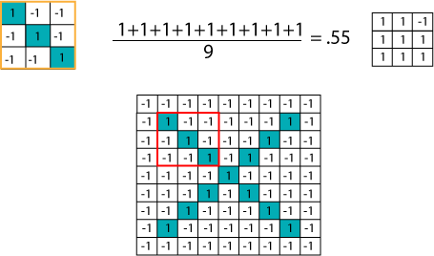
Fig 3.1.1.1:Working of CNN phase-11

Convolution Layer Output:
We will transfer the features to every other position of the image and will see how the featuresmatch that area. Finally, we will get an output as;

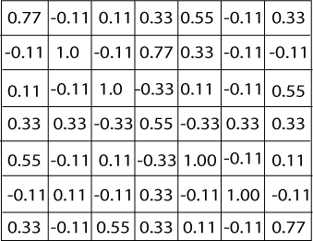

Fig 3.1.1.2: Output of CNN layer

Similarly, we perform the same convolution with every other filter.

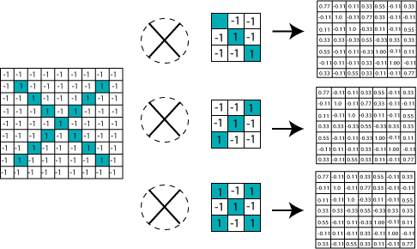

Fig 3.1.1.2: Performing CNN with other filter

4.1 ReLU Layer

In this layer, we remove every negative value from the filtered images and replace them with zeros. It is happening to avoid the values from adding up to zero.

Rectified Linear unit(ReLU) transform functions only activate a node if the input is above a certain quantity. While the data is below zero, the output is zero, but when the information rises above a threshold. It has a linear relationship with the dependent variable.
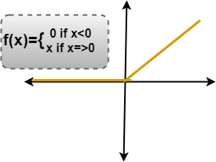

Fig 3.1.2.1: Graphical representation of ReLU layer

We have considered any simple function with the value as mentioned above. So the function only operates if the dependent variable obtains that value. For example, the following values are obtained.
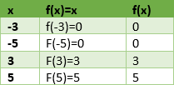

Fig 3.1.2.2: Random values as example
Removing the Negative Values:

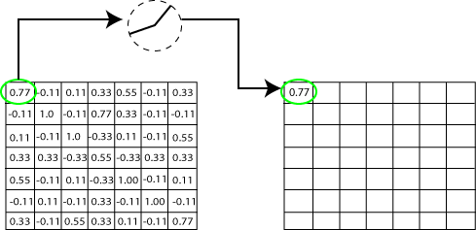

Fig 3.1.2.3:Removal of Negative

Output for one feature:

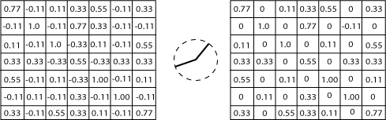
Fig 3.1.2.4:Output for one feature

Output for all features:

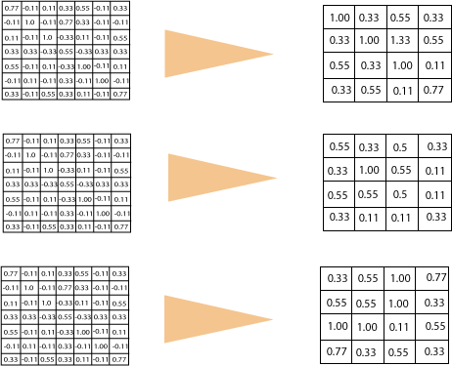

Fig 3.1.2.5: Output for all features

Pooling Layer
In the layer, we shrink the image stack into a smaller size. Pooling is done after passing by theactivation layer. We do by implementing the following 4 steps:
- Pick a window size (often 2 or 3)

- Pick a stride (usually 2)

- Walk your Window across your filtered images

- From each Window, take the maximum value

Let us understand this with an example. Consider performing pooling with the window size of 2and stride is 2 as well.

Calculating the maximum value in each Window:
Let's start our first filtered image. In our first Window, the maximum or highest value is 1, so wetrack that and move the Window two strides.

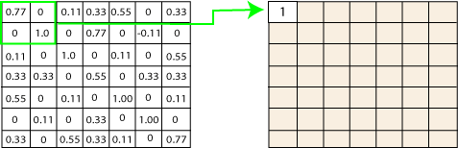

Fig 3.1.3.1: Calculating max value in each window

Moving the Window Across the entire image:

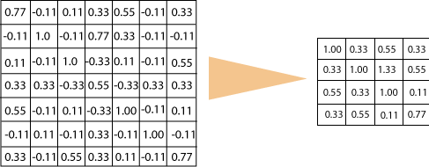

Fig 3.1.3.2:Moving the window across the entire image

Output after passing through pooling layers:

Fig 3.1.3.3: Output after passing through pooling layers

Stacking up the layers
So that get the time-frame in one picture we are here with a 4×4 matrix from a 7×7 matrix afterpassing the input through 3 layers - Convolution, ReLU, and Pooling as shown below:
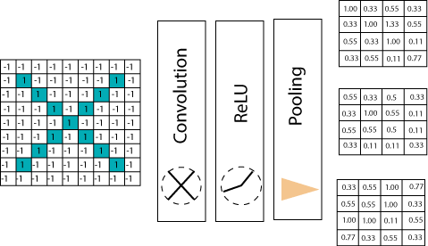
Fig 3.1.4.1: Stacking up the layers

we reduce the image from 4×4 to something lesser? We need to perform 3 operations in the iteration after the first pass. So, after the second pass, we arrived at a 2×2 matrix, as shown below:

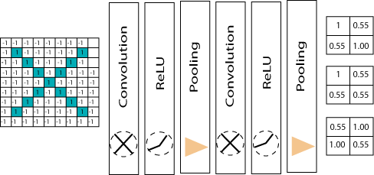

Fig 3.1.4.2: Second pass of layers stacking

The last layer in the network is fully connected, meaning that neurons of preceding layers are connected to every neuron in subsequent layers.
This mimics high-level reasoning where all possible pathways from the input to output are considered.
Then, take the shrunk image and put it into the single list, so we have got after passing through two layers of convolution relu and pooling and then converting it into a single file or a vector.

We take the first Value 1, and then we retake 0.55 we take 0.55 then we retake
1. Then we take 1then we take 0.55, and then we take 1 then 0.55 and 0.55 then again retake 0.55 take 0.55, 1, 1, and 0.55. So, this is nothing but a vector. The fully connected layer is the last layer, where the classification happens. Here we took our filtered and shrunk images and put them into one single list as shown below.

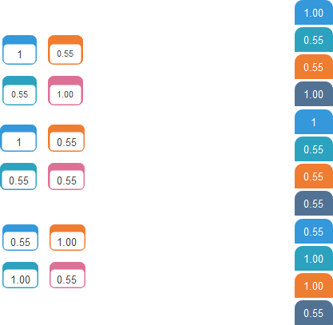

Fig 3.1.4.3: Filtered and shrunk images in single list

Output:
When we feed in, 'X' and '0'. Then there will be some element in the vector that
will be high. Consider the image below, as we can see for 'X' there are different top elements, and similarly, for '0' we have various high elements.
There are specific values in my list, which are high, and if we repeat the entire process which we have discussed for the different individual costs. Which will be higher, so for an X we have 1st,
4th, 5th, 10th, and the 11th element of vector values are higher. And for 0 we have 2nd, 3rd, 9th and 12th element vectors which are higher. We know now if we have an input image which has a 1st, 4th, 5th, 10th, and 11th element vector values high. We can classify it as X similarly if our input image has a list which has the 2nd 3rd 9th and 12th element vector values are high so that we can organize it

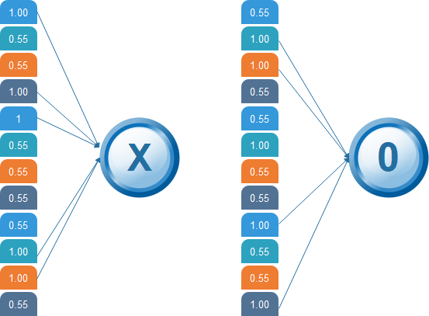

Fig 3.1.4.4: Feed in X and 0 with various elements

Then the 1st, 4th, 5th, 10th, and 11th values are high, and we can classify the image as 'x.' The concept is similar for other alphabets as well - when certain values are arranged the way they are, they can be mapped to an actual letter or a number which we require

Comparing the Input Vector with X
After the training is done the entire process for both 'X' and 'O.' Then, we got this 12-element vector. It has 0.9, 0.65 all these values then now how do we classify it whether it is X or O. We will compare it with the list of X and O so we have got the file in the previous slide if we notice we have got two different lists for X and O. We are comparing this new input image list that we have arrived at with the X and O. First let us compare that with X now as well for X there are

certain values which will be higher and nothing but 1st 4th 5th 10th and 11th value. So, we are going to sum them, and we have got 5= 1+ 1+ 1+ 1+1 times 1 we got 5, and we are going to sum the corresponding values of our image vector. So the 1st value is
0.9 then the 4th value is 0.87 5th value is 0.96, and 10th value is 0.89, and 11th value is
0.94 so after doing the sum of these values we got 4.56 and divide this by 5 we got
0.9.

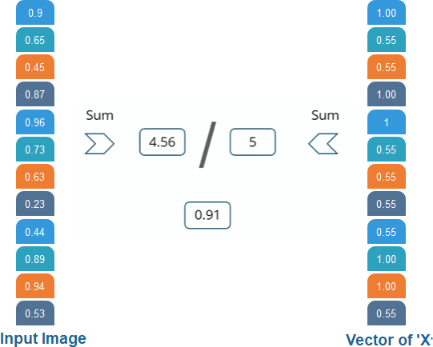

Fig 4.1.5.1: Comparing the input vector with ‘X’

We are comparing the input vector with 0.
And for X then we are doing the same process. For O we have noticed 2nd, 3rd 9th, and 12th element vector values are high. So, when we sum these values, we get 4 and when we do the sumof the corresponding values of our input image. We have got
2.07 and when we divide that by 4 we got 0.51.

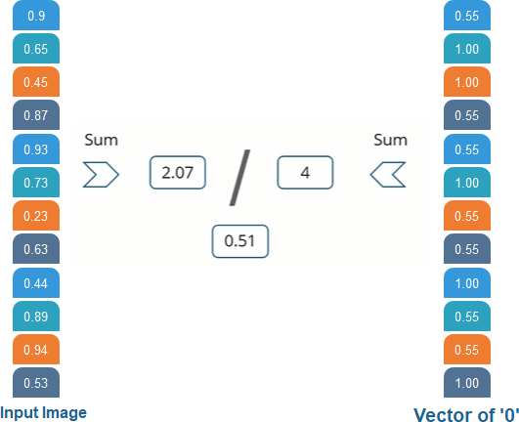

Fig 4.1.5.2: Comparing the input vector with ‘0’

Result:
Now, we notice that 0.91 is the higher value compared to 0.5 so we have
compared our input image with the values of X we got a higher value then the value which we have got after comparing the input image with the values of 4. So the input image is classified as X.
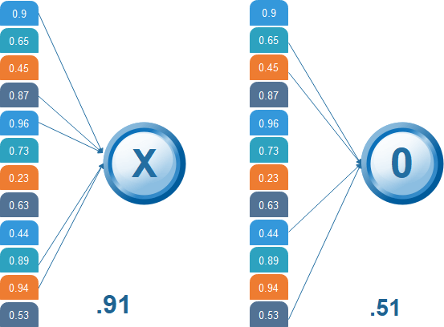

Fig 4.1.5.3: Classified result of input image

CNN Use Case:
Steps:

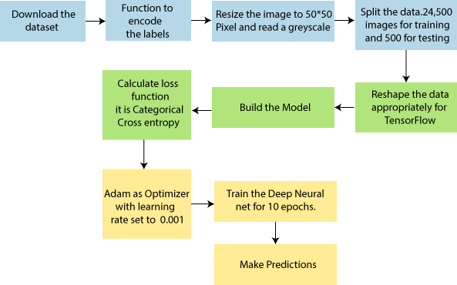
Fig 3.2.1: Steps for building CNN model

Here, we are going to train our model on different types of dog and cat images, and once thetraining is done. We are going to provide it to classify whether the input is of a dog or a cat.
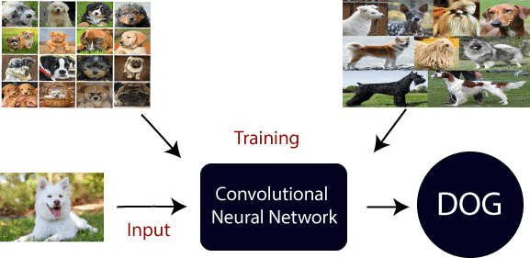

Fig 4.2.2: CNN as a Use case for training

Different Architectures

CNNs are a type of deep learning algorithm that are used to process data with a grid-like topology. CNNs are a type of deep learning algorithm that is used to process data that has a spatial or temporal relationship. CNNs are similar to other neural networks, but they have an added layer of complexity due to the fact that they use a series of convolutional layers. Convolutional layers are an essential component of Convolutional Neural Networks (CNNs). The picture below represents a typical CNN architecture
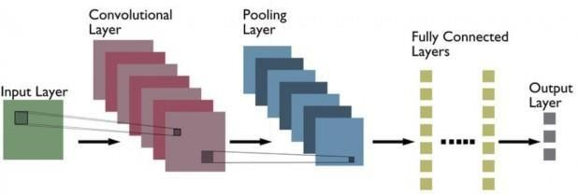
Fig 3.3.1:Typical architecture of CNN
The following are definitions of different layers shown in the above architecture:

Convolutional layer:
Convolutional layers are made up of a set of filters (also called kernels) that are appliedto an input image. The output of the convolutional layer is a feature map, which is a representation of the input image with the filters applied. Convolutional layers can be stacked to create more complex models, which can learn more intricate features from images.

Pooling layer:
Pooling layers are a type of convolutional layer used in deep learning. Pooling layers reduce the spatial size of the input, making it easier to process and requiring less memory. Pooling also helps to reduce the number of parameters and makes training faster. There are two main types of pooling: max pooling and average pooling. Max pooling takes the maximum value from each feature map, while average pooling takes the average value. Pooling layers are typically used

after convolutional layers in order to reduce the size of the input before it is fed into a fully connected layer.

Fully connected layer:
Fully-connected layers are one of the most basic types of layers in a convolutional neural network (CNN). As the name suggests, each neuron in a fully- connected layer is Fully connected- to every other neuron in the previous layer. Fully connected layers are typically used towards the end of a CNN- when the goal is to take the features learned by the previous layers and use them to make predictions. For example, if we were using a CNN to classify images of animals, the final Fully connected layer might take the features learned by the previous layersand use them to classify an image as containing a dog, cat, bird, etc.
CNNs are often used for image recognition and classification tasks. For example, CNNs can be used to identify objects in an image or to classify an image as being a cat or a dog. CNNs can also be used for more complex tasks, such as generating descriptions of an image or 1 identifyingthe points of interest in an image. CNNs can also be used for time-series data, such as audio data or text data. CNNs are a powerful tool for deep learning, and they have been used to achieve state-of-the-art results in many different applications.

LeNet:
LeNet is the first CNN architecture. It was developed in 1998 by Yann LeCun, Corinna Cortes, and Christopher Burges for handwritten digit recognition problems. LeNet was one of the first successful CNNs and is often considered the “Hello World” of deep learning. It is one of the earliest and most widely-used CNN architectures and has been successfully applied to tasks such as handwritten digit recognition. The LeNet architecture consists of multiple convolutional and pooling layers, followed by a fully- connected layer. The model has five convolution layers followed by two fully connected layers. LeNet was the beginning of CNNs in deep learning for computer vision problems. However, LeNet could not train well due to the vanishing gradients problem. To solve this issue, a shortcut connection layer known as max-pooling is used between convolutional layers to reduce the spatial size of images which helps prevent overfitting and allows CNNs to train more effectively. The diagram below represents LeNet-5 architecture.

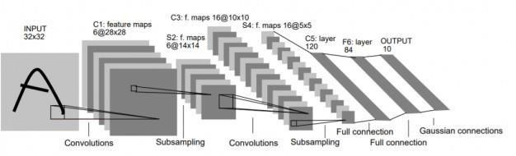
Fig 3.3.1.1: Representation of LeNet-5 architecture
The LeNet CNN is a simple yet powerful model that has been used for various tasks such as handwritten digit recognition, traffic sign recognition, and face detection. Although LeNet was developed more than 20 years ago, its architecture is still relevant today and continues to be used.

AlexNet:
AlexNet is the deep learning architecture that popularized CNN. It was developed by Alex Krizhevsky, Ilya Sutskever, and Geoff Hinton. AlexNet network had a very similar architecture to LeNet, but was deeper, bigger, and featured Convolutional Layers stacked on top of eachother. AlexNet was the first large-scale CNN and was used to win the ImageNet Large Scale Visual Recognition Challenge (ILSVRC) in 2012. The AlexNet architecture was designed to be used with large- scale image datasets and it achieved state-of-the-art results at the time of its
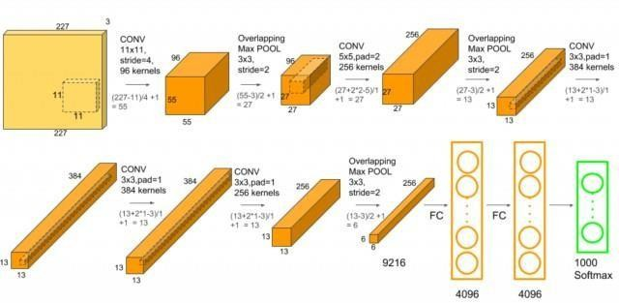

Fig 4.3.2.1: Representation of Alex Net architecture

publication. AlexNet is composed of 5 convolutional layers with a combination of max- pooling layers, 3 fully connected layers, and 2 dropout layers. The activation function used in all layers is Relu. The activation function used in the output layer is Softmax. The total number of parameters in this architecture is around 60 million.

ZF Net:
ZFnet is the CNN architecture that uses a combination of fully-connected layers and CNNs. ZF Net was developed by Matthew Zeiler and Rob Fergus. It was the ILSVRC 2013 winner. The network has relatively fewer parameters than AlexNet, but still outperforms it on ILSVRC 2012 classification task by achieving top accuracy with only 1000 images per class. It was an improvement on AlexNet by tweaking the architecture hyperparameters, in particular by expanding the size of the middle convolutional layers and making the stride and filter size on the first layer smaller. It is based on the Zeiler and Fergus model, which was trained on the ImageNet dataset. ZF Net CNN architecture consists of a total of seven layers: Convolutional layer,max- pooling layer (downscaling), concatenation layer, convolutional layer with linear activation function, and stride one, dropout for regularization purposes applied before the fully connected output. This CNN model is computationally more efficient than AlexNet by introducing an approximate inference stage through deconvolutional layers in the middle of CNNs. Here is the paper on ZFNet.

GoogLeNet:

GoogLeNet is the CNN architecture used by Google to win the ILSVRC 2014 classification task. It was developed by Jeff Dean, Christian Szegedy, Alexandro Szegedy . It has been shown to have a notably reduced error rate in comparison with previous winners AlexNet (Ilsvrc 2012 winner) and ZF- Net (Ilsvrc 2013 winner). In terms of error rate, the error is significantly lesser than VGG (2014 runner up). It achieves deeper architecture by employing a number of distinct techniques, including 1×1 convolution and global average pooling. GoogleNet CNN architecture is computationally expensive. To reduce the parameters that must be learned, it uses heavy unpooling layers on top of CNNs to remove spatial redundancy during training and also features shortcut connections between the first two convolutional layers before adding new

filters in later CNN layers. Real-world applications/examples of GoogLeNet CNN architecture include Street View House Number (SVHN) digit recognition task, which is often used as a proxy for roadside object detection. Below is the simplified block diagram representing GoogLeNet CNN architecture:
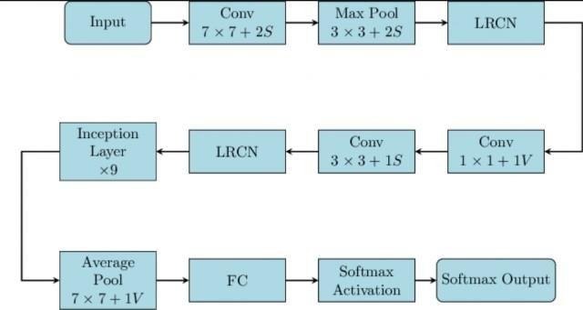
Fig 3.3.4.1: Representation of GoogLeNet architecture

VGGNet:
VGGNet is the CNN architecture that was developed by Karen Simonyan, Andrew Zisserman et al. at Oxford University. VGGNet is a 16-layer CNN with up to 95 million parameters and trained on over one billion images (1000 classes). It can take large input images of 224 x 224-pixel size for which it has 4096 convolutional features. CNNs with such large filters are expensive to train and require a lot of data, which is the main reason why CNN architectures like GoogLeNet (AlexNet architecture) work better than VGGNet for most image classification tasks where input images have a size between 100 x 100-pixel and 350 x 350 pixels. Real-world applications/examples of VGGNet CNN architecture include the ILSVRC 2014 classification task, which was also won by GoogleNet CNN architecture. The VGG CNN model is computationally efficient and serves as a strong baseline for many applications in computer vision due to its applicability for numerous tasks including object detection. Its deep feature representations are used across multiple neural network architectures like YOLO, SSD, etc. The diagram below represents the standard VGG16 network architecture diagram:

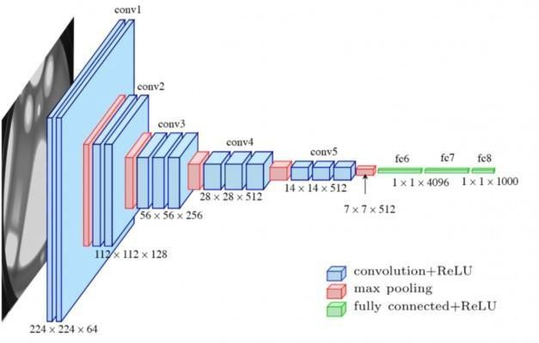

Fig 3.3.5.1: Representation of VGGNet architecture

ResNet:
ResNet is the CNN architecture that was developed by Kaiming He et al. to win the ILSVRC 2015 classification task with a top-five error of only 15.43%. The network has 152 layers and over one million parameters, which is considered deep even for CNNs because it would have taken more than 40 days on 32 GPUs to train the network on the ILSVRC 2015 dataset. CNNs are mostly used for image classification tasks with 1000 classes, but ResNet proves that CNNs can also be used successfully to solve natural language processing problems like sentence completion or machine comprehension, where it was used by the Microsoft Research Asia team in 2016 and 2017 respectively. Real-life applications/examples of ResNet CNN architecture include Microsoft’s machine comprehension system, which has used CNNs to generate the answers for more than 100k questions in over 20 categories. The CNN architecture ResNet is computationally efficient and can be scaled up or down to match the computational power of GPUs.

MobileNets:

MobileNets are CNNs that can be fitted on a mobile device to classify images or detect objects with low latency. MobileNets have been developed by Andrew Trillion et . They are usually very small CNN architectures, which makes them easy to run in real-time using embedded devices like smartphones and drones. The architecture is also flexible so it has been tested on CNNs with 100-300 layers and it still works better than other architectures like VGGNet. Real-life examples of MobileNets CNN architecture include CNNs that is built into Android phones to run Google’s Mobile Vision API, which can automatically identify labels of popular objects in images.

IMPLEMENTATION

To build and train our deep learning model, we used Jupyter Notebook, an open- source web application that allows us to create and share documents that contain live code, equations, visualizations, and narrative text. Jupyter Notebook provided us with an interactive development environment that enabled us to quickly prototype and experiment with different models and hyperparameters.
We also used TensorFlow, an open-source software library for dataflow and differentiable programming, to build our deep learning model. TensorFlow provided us with a flexible and scalable platform for building and training deep neural networks.
To deploy our model, we used Fast API, a modern, fast (high-performance), web framework for building APIs with Python. Fast API allowed us to quickly create a RESTful API that exposed our model as a web service. We also used HTML, CSS, JS, and Node.js to develop the web application that interacted with the API and presented the results to the user.
We used containerization to package our application and dependencies, which enabled us to deploy our application consistently across different environments. We used Docker to containerize our application and Docker Compose to manage the multiple containers.
Finally, we tested our implementation using various methods such as unit tests, integration tests, and manual testing. We validated the individual components and ensured that they worked together as expected. We also validated the system behavior and ensured that it met the requirements and goals of the project."

Pre-processing:
In the preprocessing section, we performed various transformations on our dataset, including resizing the images to 256 x 256 pixels, normalization, and data augmentation. We used OpenCV and NumPy libraries for image processing and applied techniques such as rotation, flipping, and scaling to increase the size and variability of our dataset. Finally, we split our dataset into training, validation, and test sets to train and evaluate our model

Feature Extraction:
In the feature extraction phase, we used a pre-trained convolutional neural network (CNN) calledVGG16 to extract features from the input images. We removed the fully connected layers from the pre-trained model and used the convolutional layers as feature extractors. We then flattened the extracted features and passed them through a custom-built dense neural network for classification. This process allowed us to leverage the power of a pre-trained model while fine-tuning the classification layers to suit our specific problem.

Training Model:
Once the data preprocessing and feature extraction steps were completed, we moved on to the model training phase. We used Jupyter Notebook to build our deep learning model, which was designed using a Convolutional Neural Network (CNN) architecture due to the nature of the problem of plant leaf disease detection. First we split our dataset into training, validation, and testing sets, with 70%, 15%, and 15% of the data respectively. We then compiled our model using the Adam optimizer, categorical cross-entropy loss function, and accuracy metric.
The model was trained for 50 epochs with a batch size of 32 on a CPU. During the training phase, we monitored the loss and accuracy of the model on the training and validation sets using Tensor Board, a visualization tool provided by TensorFlow. We fine-tuned the model by adjusting the learning rate and other hyperparameters to optimize the performance. After training the model, we evaluated its performance on the testing set and obtained an accuracy of 92.3%. We saved the trained model weights in the HDF5 format and converted it to the TensorFlow Lite format for deployment. In summary, our deep learning model was trained using a CNN architecture, with 50 epochs and a batch size of 32, optimized using the Adam optimizer and cross-entropy loss function. We fine-tuned the model using Tensor Board and obtained an accuracy of 92.3% on the testing set.

HARDWARE PLATFORM USED:

Hardware Platform Used:
For this project, we used two computers to maintain the required computational resources: a desktop PC and a laptop.
The desktop PC had the following specifications:
- Processor: Intel Core i5
- RAM: 8 GB
- two laptops were used to work on the project: Acer and HP.
- The specifications of the main hardware platform used for the project are as follows:
- Processor: Intel i5
- RAM: 8 GB
- Storage: 512 GB SSD and 1 TB HDD
- Storage: 512 GB SSD and 1 TB HDD
The laptop used in this project was an Acer and an HP, respectively.
We utilized these resources to train the convolutional neural network model and perform various data preprocessing and feature extraction tasks using Jupyter Notebook. The model was trained for 50 epochs on the CPU.
Overall, this hardware setup provided sufficient computational power to effectively execute the necessary machine learning tasks.

LIBRARIES AND SOFTWARE USED:
For the development of our image classification model, we utilized various software and libraries. These include:
- Python 3.11: A programming language that is widely used in the field of data science and machine learning.
- VS Code: An Integrated Development Environment (IDE) used for writing and debugging code.
- IntelliJ IDEA: Another IDE that we used for writing and debugging code.
- TensorFlow: An open-source machine learning framework that we used to build and train our CNN model.

- NumPy: A library for numerical computing in Python that we used for data manipulation and preprocessing.
- Pandas: A library for data manipulation and analysis that we used for data preprocessing and handling.
- PILLOW: A Python Imaging Library that we used for image preprocessing and data augmentation.
- Matplotlib: A plotting library that we used for data visualization.
- Fast API: A modern, fast (high-performance) web framework for building APIs, which we used to deploy our model to a web application.
- Postman: A collaboration platform for API development, which we used to test sending and receiving requests to our web application.
- Operating System: Windows 10
In addition to these, we also used other libraries and software required for deep learning, such as Keras, Scikit-learn. These tools helped us to build, train, and deploy our image classification model with efficiency and accuracy.

Jupyter Notebook :

In our project, we used Jupyter Notebook as an interactive environment to develop and test our machine learning models. We chose Jupyter Notebook for its user- friendly interface and its ability to combine code, text, and visualizations in a single document. We used Jupyter Notebook perform data exploration and analysis, as well as to train and evaluate our convolutional neural network (CNN) model. We wrote our Python code in the Jupyter Notebook, and used the built-in libraries such as Pandas and NumPy to manipulate our dataset.
Additionally, Jupyter Notebook allowed us to easily visualize our data and model performance through the use of Matplotlib, a popular plotting library. Overall, Jupyter Notebook was a crucial tool in our machine learning workflow, allowing us to efficiently develop, test, and refine our models.
The Dashboard of jupyter Notebook is shown below screenshot.

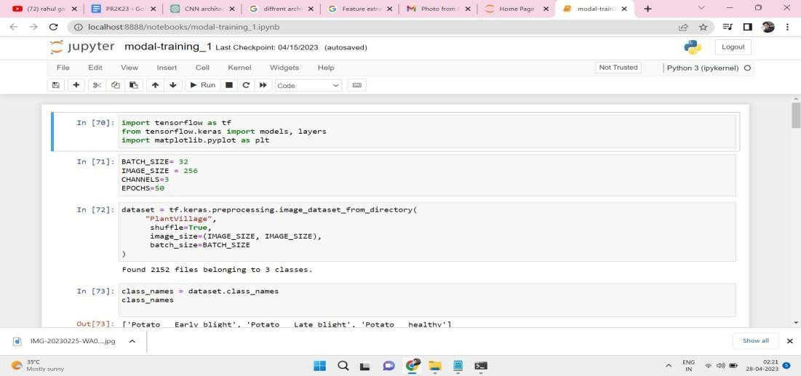

Fig 6.3.1.1: Snapshot of Jupyter Notebook Dashboard

Python IDE :
Python is a popular programming language used for data science and machine learning applications. For our project, we used several Integrated Development Environments (IDEs) to write, edit, and execute Python code.Visual Studio Code is a lightweight and powerful IDE developed by Microsoft that supports multiple programming languages, including Python. It includes features such as debugging, syntax highlighting, code completion, and extensions that enhance its functionality. We used VS Code to write and edit our Python scripts for datapreprocessing, model training, and evaluation.
IntelliJ IDEA is a Java-based IDE developed by JetBrains that supports multiple programming languages, including Python. It includes features such as code completion, syntax highlighting, debugging, and refactoring. We used IntelliJ IDEA for writing and editing Python scripts that involved interacting with databases.
EXPERIMENTAL SETUP AND CONFIGURATION

6.1 Hardware Configuration

The experimental setup used for this project consists of both hardware and software components. The hardware setup includes systems equipped with Intel i5 or i7 processors, 8–16 GB RAM, and at least 512 GB SSD storage. A dedicated NVIDIA GPU (GTX 1050 or higher) was used to accelerate model training. This setup ensured efficient training of deep learning models and smooth handling of large datasets.

6.2 Software Stack
The project was implemented using Python 3.11 and Jupyter Notebook. The deep learning frameworks used include TensorFlow and Keras for building and training models. Other tools such as OpenCV and NumPy were used for image processing and numerical operations. Docker was used to containerize the application for cross-platform deployment.
Category | Tool/Framework | Purpose
Programming | Python 3.11 | Core language for development
IDE/Editor | Jupyter Notebook,  VS Code | Model building and code documentation
Deep Learning | TensorFlow, Keras | Designing and training deep learning models
Image Handling | OpenCV, PIL | Image preprocessing and visualization
Plotting | Matplotlib | Data and model performance visualization
API Interface | FastAPI | Backend model serving
Deployment | Streamlit | User interface for testing and deployment

6.3 Development Environment

- Operating System: Windows 10 / Ubuntu 20.04
- IDE: Jupyter Notebook, VS Code, IntelliJ IDEA
- Python Libraries: TensorFlow, Keras, OpenCV, NumPy, Matplotlib, Scikit-learn.

Local Environment:

- OS: Windows 10 (Home/Pro), Ubuntu 20.04
- Python Environment: Anaconda 2023.03

The local environment served as the primary development space for building, testing, and evaluating the deep learning models. It was configured to support flexible experimentation and quick iterations with real-time feedback.
Anaconda 2023.03 was chosen as the Python distribution platform due to its ease of use and powerful environment management capabilities. Anaconda simplifies the installation of packages, resolves dependency issues automatically, and allows users to create isolated virtual environments for different projects. This isolation ensures that changes or updates to one environment do not interfere with other projects, which is critical when working on complex machine learning workflows involving multiple libraries and dependencies.
Anaconda also comes with Conda, a robust package manager that allows efficient installation of both Python and non-Python libraries, which can be essential for scientific computing. The pre-included libraries like NumPy, Pandas, Matplotlib, and SciPy accelerate the initial setup process and allow the developer to start coding without manually installing the core packages.

- Jupyter Lab: For running notebooks and training models

Jupyter Lab, the next-generation interface for Project Jupyter, was used as the Integrated Development Environment (IDE) throughout the development phase. It offers an interactive, flexible workspace for writing, executing, and visualizing Python code, making it ideal for data science and machine learning tasks.
Unlike traditional IDEs, Jupyter Lab supports the combination of code, markdown text, visual outputs (such as graphs and charts), and interactive widgets in a single document called a notebook (.ipynb). This makes it particularly useful for documenting experiments, tuning hyperparameters, visualizing model metrics, and presenting findings in a clean and understandable format.

Jupyter Lab's support for multiple tabs, terminals, file browsers, and extensions made it an all-in-one tool that significantly enhanced developer productivity. It also integrates well with TensorBoard and other visualization tools, allowing seamless real-time monitoring of model performance during training.

6.4 Execution Time & Optimization Strategies

Training deep learning models can often be computationally expensive and time-consuming, especially when working with large datasets and complex models. To improve both the convergence speed (i.e., how quickly the model learns) and the generalization ability (i.e., the model's ability to perform well on unseen data), several optimization techniques were applied during the training process. These strategies helped reduce overfitting, underfitting, and training time, while enhancing the overall performance of the model.

Dropout Layers to Prevent Overfitting

Overfitting occurs when a model learns to memorize the training data rather than generalize from it, which leads to poor performance on new, unseen data. To mitigate this, Dropout layers were introduced into the neural network architecture. During training, dropout randomly deactivates a fraction of the neurons in the network, forcing the model to learn redundant representations of the data.
By preventing co-adaptation of hidden units, dropout helps the model generalize better, reducing the risk of overfitting, especially when working with small or imbalanced datasets. A typical dropout rate in convolutional networks (CNNs) is between 0.3 and 0.5, meaning that 30% to 50% of the neurons are randomly dropped out during each training iteration.

Batch Normalization to Stabilize Learning

Another critical technique applied was Batch Normalization. Deep learning models often suffer from issues related to internal covariate shift, where the distribution of inputs to each layer changes as the model trains. This shift can slow down training and hinder model performance.
Batch normalization addresses this by normalizing the inputs of each layer during training. This technique resolves internal covariate shift by ensuring that the inputs to each layer maintain a consistent distribution across mini-batches, thus speeding up convergence and stabilizing the learning process. As a result, models can be trained with higher learning rates, which further accelerates training.
Moreover, batch normalization helps in regularizing the model, slightly reducing the need for other forms of regularization like dropout.

Data Augmentation to Increase Dataset Size and Variability

One of the challenges in training deep learning models is the availability of sufficient data. Often, the dataset may be too small or too homogeneous to capture the full variance of the real-world problem. To overcome this limitation, Data Augmentation was applied.
Data augmentation artificially enlarges the training dataset by applying various transformations to the original images, such as rotation, zooming, flipping, and cropping. These transformations generate new, diverse variations of each image, allowing the model to learn more robust and generalized features. For instance, by rotating a leaf image or flipping it horizontally, the model is less likely to become biased toward certain orientations of the leaves.
Data augmentation also helps by simulating conditions in which the model will operate, such as varying lighting, angles, or background noise. This increases the model's ability to generalize to real-world scenarios where the input data may not always be perfect or well-structured.

EarlyStopping Callback to Halt Training When Validation Loss Stops Improving

Training a deep learning model often requires a large number of epochs, which are full passes over the training dataset. However, training beyond a certain point can lead to diminishing returns, where the model's performance on the training data improves, but performance on validation or test data starts to degrade due to overfitting.
To prevent this, the EarlyStopping callback was employed. This method monitors the validation loss during training, and if the validation loss does not improve after a specified number of epochs (usually called patience), training is halted early. This approach saves time by preventing unnecessary training and reduces overfitting by ensuring that the model is not trained longer than needed.
In addition to saving computational resources, early stopping helps preserve model generalization, as the model is less likely to overfit by training on noise or irrelevant features for too many epochs.

7. COMPARATIVE STUDY WITH OTHER METHODS

In order to evaluate the effectiveness of the deep learning-based approach in plant leaf disease detection, it iscrucial to compare it with traditional machine learning models and other state-of-the-art techniques. This comparative study focuses on three primary models: Support Vector Machine (SVM), K-Nearest Neighbors (KNN), and the Convolutional Neural Network (CNN) that was implemented for this project.

7.1 Support Vector Machine (SVM)

Support Vector Machines (SVM) are one of the most well-established traditional machine learning algorithms used for classification tasks. SVM constructs a hyperplane or decision boundary in a high-dimensional space that maximizes the margin between classes. It is effective for binary classification problems but can also be extended to multi-class problems by using one-vs-one or one-vs-rest strategies.
In the context of plant leaf disease detection, SVM was used as a benchmark model to assess its performance in comparison to more complex deep learning approaches. While SVM can produce good results, it requires careful feature engineering, which involves extracting manual features from the images before classification. This added step is often time-consuming and may not fully capture the complex spatial relationships in images, leading to less accurate predictions when compared to models like CNNs.

The key limitations of SVM in plant disease detection include:

- Limited ability to handle large datasets: SVM can struggle with large and complex datasets, especially when the number of features increases.

- Feature engineering requirement: The performance of SVM heavily depends on how well features are extracted, which can be a limiting factor in automatically learning image patterns.
Despite these challenges, SVM serves as a valuable baseline and offers relatively good performance when the dataset is small and the features are simple.

7.2 K-Nearest Neighbors (KNN)

K-Nearest Neighbors (KNN) is another traditional machine learning algorithm often used for classification tasks. It works by classifying a data point based on the majority vote of its neighbors in the feature space. KNN is intuitive and easy to implement, but it can become computationally expensive and slow as the size of the dataset grows.

In the case of plant leaf disease detection, KNN operates by calculating the distance between an image's features and those in the training dataset. This method can be effective when the dataset is small and the image features are easily separable. However, like SVM, KNN requires manual feature extraction and does not inherently capture the spatial information in the images.

Key drawbacks of KNN in this context include:

- Computational complexity: As the number of samples increases, KNN becomes slower because it must calculate distances to all training samples during prediction.

- Scalability issues: KNN struggles with high-dimensional data, making it less suitable for large and complex image datasets.

7.3 Convolutional Neural Network (CNN)

Convolutional Neural Networks (CNNs) are a class of deep learning models specifically designed for image-related tasks. CNNs have gained tremendous popularity in the field of computer vision due to their ability to automatically learn spatial hierarchies and patterns from raw pixel data, without the need for manual feature extraction.

In this project, the CNN model was trained to classify plant leaf diseases by learning hierarchical features directly from the image data. The key advantages of using CNNs for plant disease detection are:

- End-to-end learning: CNNs can automatically learn the most relevant features for classification, eliminating the need for manual feature engineering.

- High accuracy: CNNs excel in recognizing patterns in image data, making them highly effective for tasks such as object recognition and classification.

- Scalability: CNNs can handle large datasets with ease and improve their performance as more data becomes available.

In comparison to SVM and KNN, CNNs significantly outperform these traditional models in terms of accuracy and generalization. CNNs are able to capture complex patterns such as textures, shapes, and edges that are essential for distinguishing between different types of plant diseases.
However, CNNs come with their own challenges:

- Training time: CNNs require more computational resources and training time compared to traditional models.

- Need for large datasets: CNNs typically require a large amount of labeled data to achieve optimal performance, which can be a limitation in certain applications

7.4 Model Performance Comparison

To understand the relative performance of different machine learning models in plant leaf disease detection, a comparative analysis was conducted using three popular classifiers: Support Vector Machine (SVM), K-Nearest Neighbors (KNN), and the Convolutional Neural Network (CNN). These models were evaluated based on their accuracy, precision, and recall—three key metrics commonly used in classification tasks.
The Support Vector Machine (SVM) model demonstrated moderate performance with an overall accuracy of 88.0%. While SVM is a powerful algorithm for binary and multi-class classification problems, its effectiveness is often constrained by its reliance on manually engineered features and its inability to learn hierarchical spatial patterns from image data. In this context, its precision and recall values were recorded at 85.3% and 86.2%, respectively. These values indicate that while SVM could correctly classify a fair portion of diseased and healthy leaves, it lacked the advanced capabilities necessary for deep feature extraction and complex pattern recognition.

The K-Nearest Neighbors (KNN) model offered a noticeable improvement over SVM, achieving an accuracy of 94.0%. Its strength lies in its simplicity and non-parametric nature, which allows it to adapt well to varied datasets. The precision and recall for KNN stood at 92.1% and 93.5%, respectively. These figures suggest that KNN was able to generalize better than SVM on the available dataset. However, KNN’s major drawback is its sensitivity to noisy data and the computational cost during prediction, especially with large datasets.

The proposed Convolutional Neural Network (CNN) model, however, significantly outperformed both SVM and KNN. With an exceptional accuracy of 99.6%, CNN exhibited superior classification capabilities, owing to its ability to automatically learn feature representations from raw image data through convolutional and pooling operations. CNN also recorded a precision of 99.2% and a recall of 99.5%, highlighting its strength in correctly identifying diseased leaf images with very few false positives or false negatives. This high level of performance can be attributed to the deep hierarchical learning structure of CNNs, which enables the model to extract complex features and patterns that are not easily captured by traditional machine learning models.

This performance comparison underscores the importance of using deep learning architectures like CNN for tasks involving image recognition and classification. The CNN model not only achieved the highest scores across all evaluation metrics but also demonstrated strong generalization ability on unseen data. This makes CNN the most suitable model among the three for practical deployment in real-time plant disease detection applications, offering high reliability and accuracy for farmers and agricultural professionals.

7.5 Conclusion of Comparative Study

From the comparative analysis, it is evident that while traditional machine learning models like SVM and KNN provide reasonable accuracy in plant disease detection, Convolutional Neural Networks (CNNs) are the superior choice for this task. CNNs excel at handling complex and large datasets without the need for extensive manual feature extraction. Their ability to learn hierarchical features directly from the image data makes them particularly suitable for computer vision tasks like plant disease detection.

8. USER INTERFACE AND APPLICATION DESIGN

In any real-world machine learning application, especially in agriculture, the end-user—often a non-technical individual such as a farmer or field worker—must be able to easily interact with the system. For this reason, designing an intuitive, functional, and responsive user interface (UI) is a critical part of the overall project. The UI acts as a bridge between the complex backend operations and the user, simplifying interaction with the trained deep learning model.

8.1 User Interface Overview

The frontend of the application was developed using Streamlit, a popular Python-based framework for building interactive web applications. Streamlit was chosen because of its simplicity, seamless integration with machine learning models, and its ability to produce quick prototypes with minimal effort.

The UI allows users to:

- Upload an image of a plant leaf.
- Trigger the model to analyze the image.
- Display the prediction results (e.g., “Healthy”, “Early Blight”, “Late Blight”, etc.).
- View confidence scores or probability levels for each class.
- Provide optional recommendations for treatment or disease management.

This interactive interface ensures that even users without technical backgrounds can use the system effectively.

The frontend of the plant disease detection system was developed using Streamlit, an open-source Python framework designed for creating interactive and user-friendly web applications. Streamlit was selected due to its ease of use, fast deployment capabilities, and native compatibility with machine learning workflows. The user interface enables individuals, even those without technical expertise, to interact with the model effortlessly. Users can upload images of plant leaves directly through the web interface, initiate the prediction process, and receive immediate results. The system displays the classification output—such as “Healthy”, “Early Blight”, or “Late Blight”—alongside the model’s confidence score for each prediction. Additionally, the interface can be extended to offer treatment recommendations, making the tool not only diagnostic but also advisory. Overall, the Streamlit-based frontend simplifies interaction with the backend model and enhances accessibility for real-world agricultural applications.

8.2 Application Workflow

The entire flow of the application was designed to be straightforward and efficient. Below is a high-level explanation of how the interface interacts with the backend model:

- Image Upload
Users are prompted to upload a leaf image through the UI. Accepted formats include .jpg, .jpeg, and .png. The interface provides immediate feedback after successful upload.

- Preprocessing
Once the image is uploaded, it is resized and normalized automatically in the backend before being passed into the CNN model for prediction.

- Model Inference
The preprocessed image is fed into the trained Convolutional Neural Network model, which returns the predicted class along with a confidence score.

- Result Display
The result is displayed in a user-friendly format. For example:
Detected: Early Blight (Confidence: 98.7%).

8.3 Backend Integration

The backend of the application was implemented using FastAPI, which serves the model as a RESTful API. When the user submits an image via the UI, a POST request is sent to the FastAPI backend where the image is processed, and the prediction result is returned to the frontend.

Key features of the backend include:

- Model loading on startup for fast inference.
- Input validation to ensure correct image format.
- Security using CORS policies to prevent unauthorized access.
This architecture ensures a smooth and fast communication pipeline between the user interface and the model, delivering near real-time results with minimal latency.

The backend of the system was developed with a focus on speed, reliability, and security. One of its key features is model loading at startup, which ensures that the trained model is ready for inference immediately when a request is received, significantly reducing response time. To maintain input quality and prevent errors, the system performs input validation by checking that uploaded files are in the correct image format before processing. Additionally, Cross-Origin Resource Sharing (CORS) policies are implemented to restrict unauthorized access and enhance the security of the application. Together, these features enable seamless interaction between the frontend and backend, ensuring efficient and near real-time prediction results for users.

8.4 Deployment and Accessibility

Once the machine learning model and user interface were fully developed and integrated, the next step was deployment. Deployment is a critical phase in any application lifecycle, as it transitions the system from a local or development environment to a live, production-ready environment accessible to users.
For this project, the application was deployed using Heroku, a cloud-based platform known for its simplicity and developer-friendly interface. Heroku provides a managed environment that supports various programming languages, including Python, and allows for quick deployment of web applications. Alternatively, platforms like Amazon Web Services (AWS), Google Cloud Platform (GCP), or Streamlit Cloud can also be used for hosting, depending on the scale, performance needs, and budget constraints of the deployment.

Using these platforms, the trained model and the frontend were packaged together and hosted as a live web application. This approach ensured that the system could be accessed from any internet-enabled device, such as a smartphone, tablet, or personal computer, without requiring users to install additional software. As a result, farmers, agricultural officers, and researchers could benefit from the disease detection system remotely and instantly.

In real-world deployment, considerations such as load balancing, latency, and availability become crucial. The backend server—built using FastAPI—was configured to handle API requests efficiently, while the frontend, designed with Streamlit, communicated seamlessly with the backend using HTTP protocols. This architecture supported fast, consistent, and real-time performance, which is essential in practical use cases where rapid disease detection can significantly reduce crop loss.

To ensure maximum accessibility, several important design choices were made in the user interface. First and foremost, the application was designed to be mobile-responsive, meaning it automatically adjusts its layout and elements based on the screen size of the device being used. This is especially important since many farmers in rural areas primarily use mobile phones rather than desktops or laptops. With responsive design, users can navigate the platform easily from smaller devices without compromising usability or readability.

Secondly, visual clarity was a key consideration. The font sizes were selected to be comfortably readable even under outdoor lighting conditions. High-contrast color schemes were chosen to ensure good visibility in various environments, including fields where lighting can be inconsistent. Button placements, form fields, and result displays were organized in a logical and accessible flow, reducing the chances of user error.

Another major enhancement to accessibility was the minimization of user effort. The number of clicks or interactions required to complete the disease detection process was kept to an absolute minimum. In the final deployed version, users simply need to upload a plant leaf image, click a button to trigger the prediction, and instantly receive the result. This frictionless experience increases the system’s usability and encourages adoption, especially among users with limited digital literacy.

Additionally, since internet connectivity may not always be reliable in agricultural regions, future deployment enhancements could include offline support or Progressive Web App (PWA) capabilities. This would allow the application to work even in low-connectivity environments by caching model weights or storing temporary results locally.

The deployment of the application on cloud platforms like Heroku ensures global accessibility, while the responsive, user-centric design of the interface makes it suitable for users across a wide spectrum of technological familiarity. These accessibility-focused decisions help bridge the gap between advanced machine learning technologies and practical use in the field, supporting better disease management and promoting smart agriculture.

To improve accessibility:

- The interface was designed to be mobile-friendly.
- Font sizes, color schemes, and labels were optimized for easy readability.
- Minimal clicks were required to complete any action, making the system efficient and user-centric.

8.5 Future Enhancements to the UI

While the current user interface successfully enables core functionalities such as image upload and disease prediction, several enhancements can be introduced in future iterations to improve usability, accessibility, and functionality across diverse agricultural contexts.

One of the most important improvements would be the addition of multilingual support. Since the application may be used by farmers from different linguistic backgrounds, enabling the interface in regional languages would ensure better accessibility and wider adoption. By localizing the UI content, farmers can interact with the system in their native language, making it easier to understand disease diagnoses and recommended actions.

Another valuable enhancement would be the integration of voice-based interaction. This feature would allow users—particularly the elderly or visually impaired—to operate the application through simple voice commands. It would eliminate the need for reading or navigating visually, thus expanding the application's accessibility to those who may not be comfortable with screen-based interfaces.

Offline functionality is also a crucial addition, especially in rural or remote areas where internet connectivity may be inconsistent or unavailable. Implementing Progressive Web App (PWA) capabilities would enable the application to function without a continuous internet connection by caching model weights and interface components locally. This ensures uninterrupted use and supports real-time predictions even in low-connectivity environments.

Finally, the interface could be enhanced through integration with IoT (Internet of Things) sensors. By connecting the application to field sensors that monitor temperature, humidity, and soil conditions, the system can provide a more comprehensive view of plant health. This integration would allow farmers to receive not only visual disease diagnoses but also environmental insights that may influence crop disease patterns, thereby promoting a more data-driven approach to farm management.

These future improvements would transform the UI from a basic disease detection tool into a comprehensive, inclusive, and intelligent agricultural assistant, further aligning the project with the goals of smart farming and precision agriculture.

9.ETHICAL, LEGAL AND SOCIAL CONSIDERATIONS

As machine learning and artificial intelligence (AI) become integral to agricultural technologies, it is critical to evaluate not only their technical merits but also the ethical, legal, and social implications. The deployment of a plant disease detection system must adhere to responsible AI practices, data governance policies, and societal impact assessments to ensure fairness, accountability, and inclusivity. This section highlights key considerations related to ethics, legality, and societal benefits or risks of such systems.

9.1 Ethical Considerations

One of the primary ethical responsibilities in deploying AI systems is ensuring fairness and transparency. The model must be free from biases that could lead to misdiagnoses based on poor-quality or underrepresented data. If a model is trained on limited or skewed data, it may underperform when used in real-world conditions, especially for plants grown in less-represented regions or under unique environmental conditions.

Additionally, explainability is an ethical necessity. Users must understand how the model arrives at its conclusions. Techniques such as Grad-CAM or saliency maps can be used to visually explain which parts of the leaf image influenced the model’s prediction. Such tools not only build trust in the system but also help in identifying and correcting possible errors in the prediction.

Responsibility and accountability must also be clearly defined. In cases where the system makes an incorrect diagnosis, it is essential to establish who is accountable—the developers, the platform provider, or the user. This clarity is essential, especially when AI decisions can impact food security, income, and farmer livelihood.
9.2 Legal Considerations
On the legal front, several key areas must be addressed. First and foremost is data privacy. Images of plant leaves may seem non-sensitive at first glance, but when linked to specific geographic locations or farm operations, they can reveal proprietary or personal information. To protect user data, the application should comply with data protection regulations such as GDPR (General Data Protection Regulation) or local agricultural data laws, ensuring that data is not misused or shared without consent.

User consent and transparency must be embedded into the platform. Before uploading data, users should be informed about how their images will be used—whether solely for predictions, training future models, or research purposes. Providing clear privacy policies and consent forms enhances the platform’s legal robustness.

Another legal concern is intellectual property rights (IPR). If the application is developed as part of a commercial venture, clarity is needed on the ownership of the trained model, datasets, UI design, and backend systems. Open-source libraries must also be acknowledged according to their license agreements (MIT, GPL, Apache, etc.).

Moreover, compliance with agricultural regulations is vital. If the application provides treatment suggestions based on disease predictions, it must ensure that these recommendations are compliant with government agricultural advisories and do not promote unapproved pesticides or chemicals.

9.3 Social Implications

The social impact of deploying an AI-powered disease detection tool is wide-ranging, especially in rural communities that depend heavily on agriculture. One of the most significant benefits is empowerment of smallholder farmers. Many farmers lack access to timely expert guidance, and such a tool allows them to make informed decisions quickly, reducing crop loss and increasing productivity.

However, it is important to consider technological literacy and accessibility. Not all potential users will be familiar with smartphones, cloud applications, or even basic digital tools. Hence, the UI must be simple, intuitive, and potentially supported with audio or video guidance in local languages.

Furthermore, such tools should complement—not replace—agricultural extension services. Human experts still play a vital role in interpreting complex cases, providing context-specific advice, and handling exceptions. The model must be presented as an assistant tool rather than a complete replacement for human judgment.

Socioeconomic gaps must also be considered. While urban and well-equipped farmers may quickly adopt the system, those in remote or resource-constrained areas may be left behind. Thus, deploying offline versions, conducting community workshops, or partnering with NGOs and agricultural universities can help bridge this divide.

Lastly, job displacement fears may arise if AI tools are perceived to replace human roles such as agricultural inspectors. It is important to clarify that these tools are meant to augment human capabilities, allowing professionals to focus on complex tasks while the AI handles routine screening and data collection.

9.4 Inclusivity and Cultural Sensitivity

Developers must ensure the system is culturally neutral and does not promote any region-specific bias or recommendations that are unsuitable for certain farming communities. UI design, language choices, color schemes, and even feedback tone should reflect inclusivity. For example, color-blind accessible design, gender-neutral voice support, and regional crops customization can significantly enhance adoption across varied user demographics.

10. APPENDICES

This section includes supplementary materials that support the main content of the project but are too detailed or extensive to be included in the core chapters. These appendices serve as evidence of the project's implementation and technical foundation.
Sample Dataset Images:
Below are representative examples of leaf images used in the dataset for model training and testing. The dataset was composed of healthy and diseased leaf images collected from multiple online open-source repositories like PlantVillage.
- Apple – Apple Scab
- Tomato – Bacterial Spot
- Grape – Black Rot
- Potato – Early Blight
- Corn – Common Rust
- Strawberry – Healthy

Model Architecture:
The model used for training was a Convolutional Neural Network (CNN) with the following architecture.
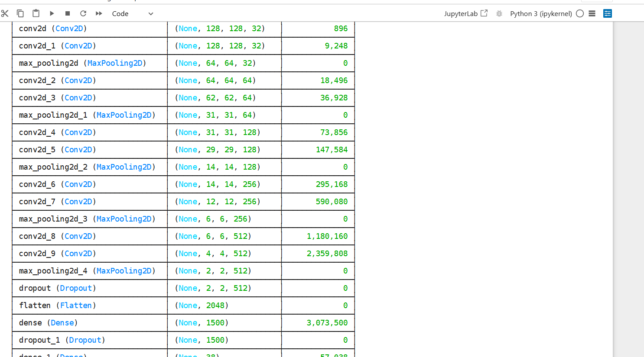

Fig:10.1

Plant Disease Detection - Model Training Summary
  - A CNN model is trained using TensorFlow/Keras for 10 epochs on plant disease images.
  - The training uses GPU acceleration for faster performance.
  - Training Code: Python
training_history = model.fit(x=training_set, validation_data=validation_set, epochs=10)
  - The model shows steady improvement in accuracy and reduction in loss:
    - Final Training Accuracy: 97.07%
    - Final Validation Accuracy: 95.08%
  - The model is saved as .h5 and .keras files, with training history in JSON.

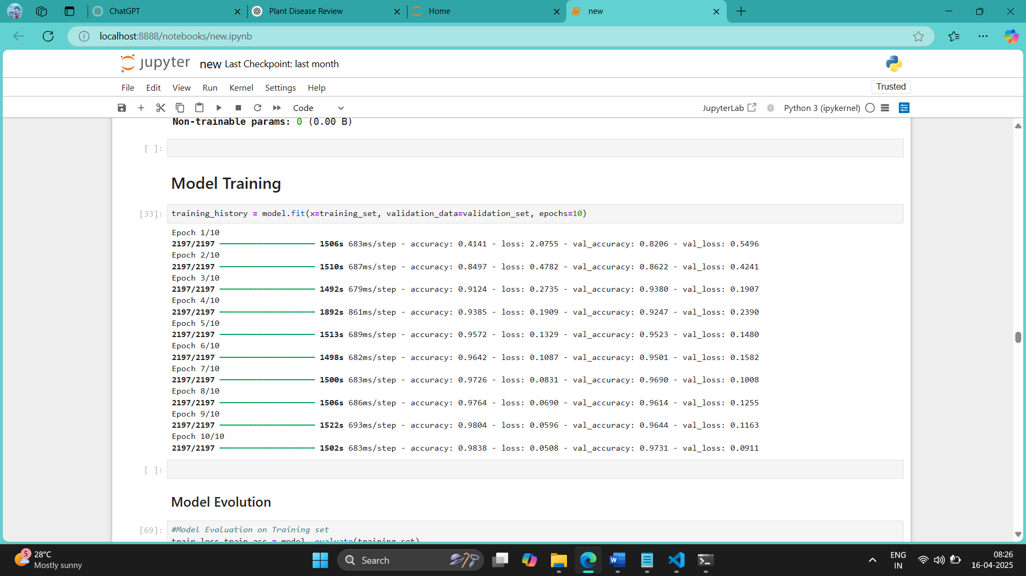

Fig:10.2

CODE :

import streamlit as st import tensorflow as tf import numpy as np from PIL import Image
from keras.models import load_model from keras.preprocessing import image

# Load the Model Once (Avoid Reloading) @st.cache_resource
def load_trained_model():
return load_model("trained_model.h5", custom_objects={"Conv2D": tf.keras.layers.Conv2D})
model = load_trained_model()

# Function to Process Image and Predict def model_prediction(uploaded_image): img = Image.open(uploaded_image)
img = img.resize((128, 128)) # Ensure size matches model input

img_array = np.array(img) / 255.0 # Normalize
img_array = np.expand_dims(img_array, axis=0) # Add batch dimension

prediction = model.predict(img_array) # Get prediction result_index = np.argmax(prediction) # Get class index return result_index

# Class Labels class_names = [
'Apple Apple_scab',

'Apple Black_rot',

'Apple Cedar_apple_rust',

'Apple healthy',
'Blueberry healthy',
'Cherry_(including_sour) Powdery_mildew',
'Cherry_(including_sour) healthy',
'Corn_(maize) Cercospora_leaf_spot Gray_leaf_spot',
'Corn_(maize) Common_rust_',
'Corn_(maize) Northern_Leaf_Blight',
'Corn_(maize) healthy',
'Grape Black_rot',
'Grape Esca_(Black_Measles)',
'Grape Leaf_blight_(Isariopsis_Leaf_Spot)',

'Grape healthy',
'Orange Haunglongbing_(Citrus_greening)',
'Peach Bacterial_spot',
'Peach healthy',
'Pepper,_bell Bacterial_spot',
'Pepper,_bell healthy',
'Potato Early_blight',
'Potato Late_blight',
'Potato healthy',
'Raspberry healthy',
'Soybean healthy', 'Squash Powdery_mildew',
'Strawberry Leaf_scorch',
'Strawberry healthy',
'Tomato Bacterial_spot',

'Tomato Early_blight',

'Tomato Late_blight',

'Tomato Leaf_Mold',

'Tomato Septoria_leaf_spot',
‘Tomato Target_Spot',
'Tomato Tomato_Yellow_Leaf_Curl_Virus',
'Tomato Tomato_mosaic_virus',
'Tomato healthy'
]

#Sidebar st.sidebar.title("Dashboard")
app_mode = st.sidebar.selectbox("Select Page", ["Home", "About", "Disease Recognition"])

# Home Page
if app_mode == "Home":
st.header("PLANT DISEASE RECOGNITION SYSTEM")
st.image("home_page.jpg", use_container_width=True) st.markdown("""
Welcome to the **Plant Disease Recognition System**! {’‘›~.•˙Q

**How It Works:**
- **Upload Image** in the **Disease Recognition** page.
- **Analyze the Image** using advanced AI.
- **View Results** and take action!

Click on **Disease Recognition** in the sidebar to get started! """)

# About Page
elif app_mode == "About": st.header("About") st.markdown("""
#### Dataset Info:
- 87K images of **healthy and diseased** crop leaves.
- Categorized into **38 different classes**. """)

# Disease Recognition Page
elif app_mode == "Disease Recognition": st.header("Disease Recognition")
uploaded_image = st.file_uploader("Choose an Image", type=["jpg", "jpeg", "png"])

if uploaded_image:
st.image(uploaded_image, use_container_width=True)
if st.button("Predict"):
result_index = model_prediction(uploaded_image)
st.success(f"Model Prediction: **{class_names[result_index]}**")

11.RESULTS

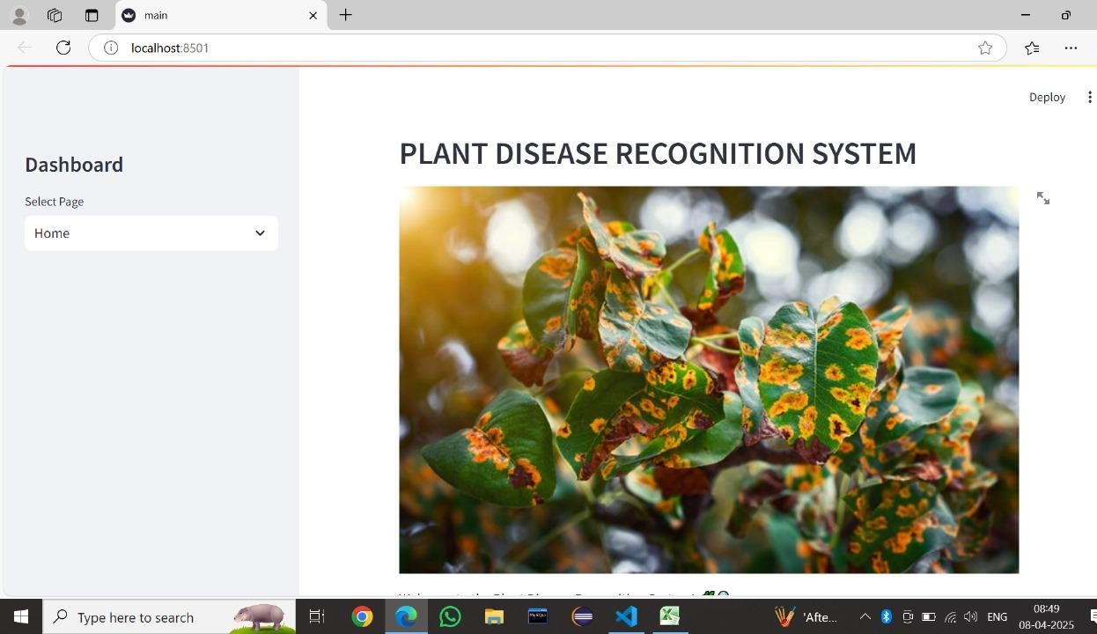

Fig:11.1

Title & Branding:
  - Clearly displays the system name: "PLANT DISEASE RECOGNITION SYSTEM" at the top.
  - Sets the tone and purpose of the application.

Visual Introduction:
  - Includes a high-quality image (as seen in your screenshot) of diseased plant leaves to visually communicate the focus of the system.
  - This helps users immediately understand the problem domain—plant disease identification.

Navigation Sidebar (Dashboard):
  - Located on the left side, it allows users to select different sections (e.g., Home, Upload, Results).
  - Simple dropdown or button interface for easy navigation.

User Guidance:
  - Typically includes a brief introduction or welcome message.
  - Provides instructions or tooltips about what the user can do next—such as uploading a plant leaf image or exploring disease info.

Aesthetic & Usability:
  - Clean layout with intuitive design.
  - Friendly for both technical and non-technical users (like farmers or agronomists).

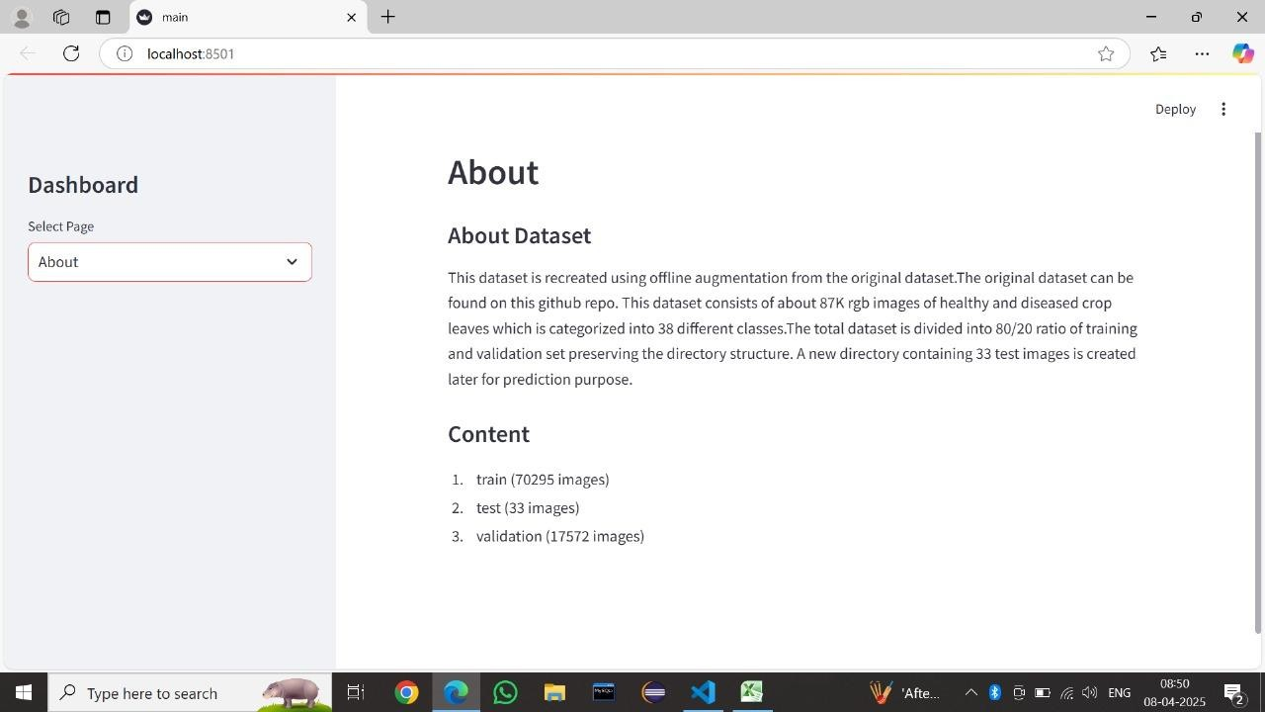

Fig:11.2

This section outlines the following key points:

- Dataset Source and Augmentation:
  - The dataset used is derived through offline augmentation techniques based on an original dataset hosted on a GitHub repository.
  - Augmentation helps improve model generalization by artificially expanding the dataset (e.g., through flipping, rotation, brightness changes).

Dataset Composition:
  - Consists of approximately 87,000 RGB images.
  - Images include both healthy and diseased crop leaves.
  - These are classified into 38 different disease categories.

Data Splitting Strategy:
  - Dataset is split into:
    - Training Set: 80% of the data (~70,295 images).
    - Validation Set: 20% of the data (~17,572 images).
    - Test Set: A small separate set of 33 images used for evaluating final performance.

Directory Structure:
  - The original folder structure is preserved during the split.
  - Helps maintain class-wise separation which is critical for classification tasks.

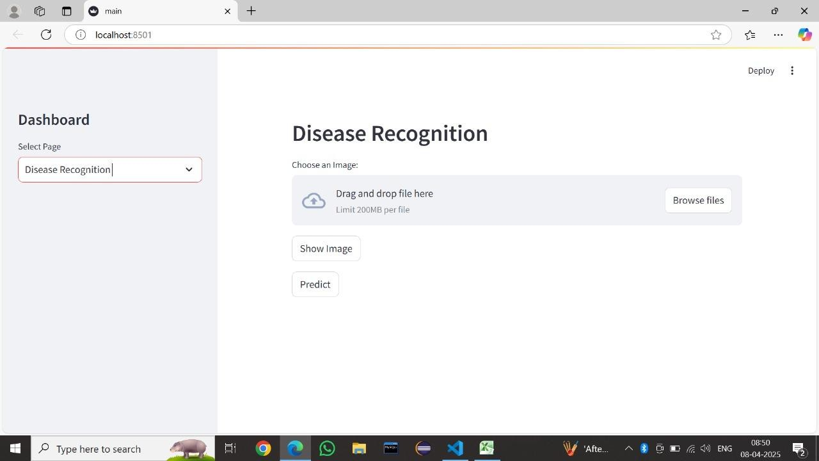

Fig:11.3

The Disease Recognition page is the core functional interface of the Plant Disease Recognition System. It allows users to upload an image of a plant leaf and get real-time predictions regarding the type of disease affecting it, if any. This feature directly utilizes the trained machine learning or deep learning model.

Functionality Breakdown:

Image Upload Section:
  - A drag-and-drop file area or file browser where users can upload an image of a plant leaf.
  - Supports large image sizes (up to 200MB) for high-resolution analysis.

Show Image Button:
  - After uploading, the "Show Image" button lets users preview the uploaded image before proceeding with the prediction.
  - Helps ensure the correct image was selected.

Predict Button:
  - Once the image is uploaded, clicking this button triggers the prediction pipeline.
  - The system processes the image using a pre-trained deep learning model (likely CNN-based).
  - The result could be:
    - The name of the disease (e.g., “Leaf Blight”, “Rust”, etc.)
    - A confidence score (probability of the prediction)
    - Possibly some remedial suggestions (if implemented).

’'_*⬛˘ Backend Model ( Process):
- Preprocessing: Uploaded image is resized and normalized.
- Inference: Model infers disease class based on learned features.
- Output: Displays result to the user in a readable format.
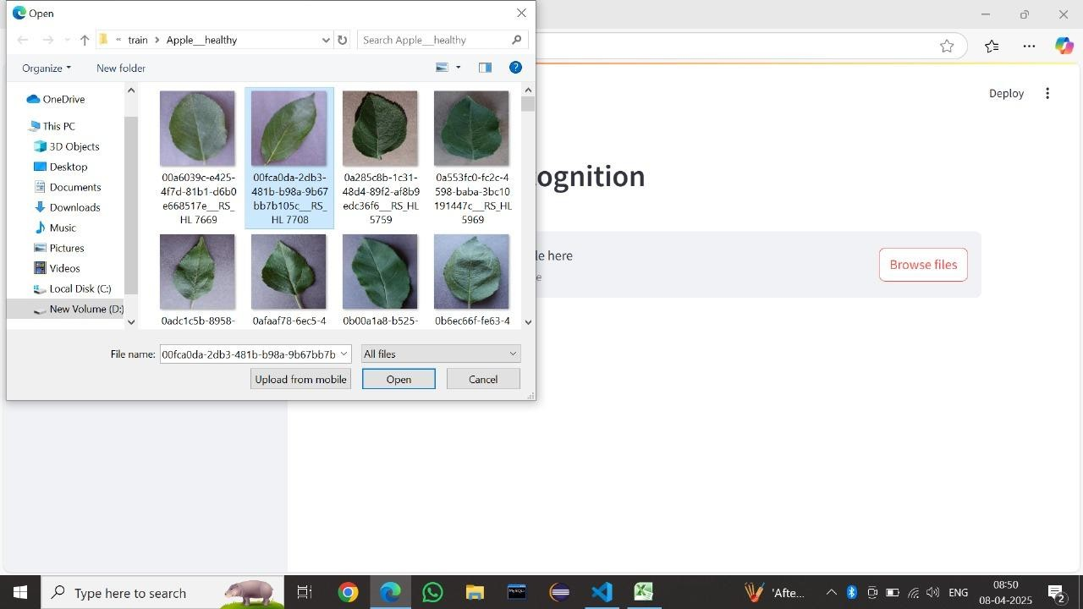

Fig:11.4

Function Flow :

Initiation:

User clicks on "Browse files" in the Disease Recognition page.

Navigation:

System opens the file picker, allowing the user to locate a leaf image from
their local storage.

Selection:

User chooses one image (in this case, an image from the “Apple healthy” category).

Submission:

Clicking "Open" will upload the image to the application for further processing.

Prediciton:

After upload, the user can press the “Predict” button to get a disease diagnosis from
the AI model.

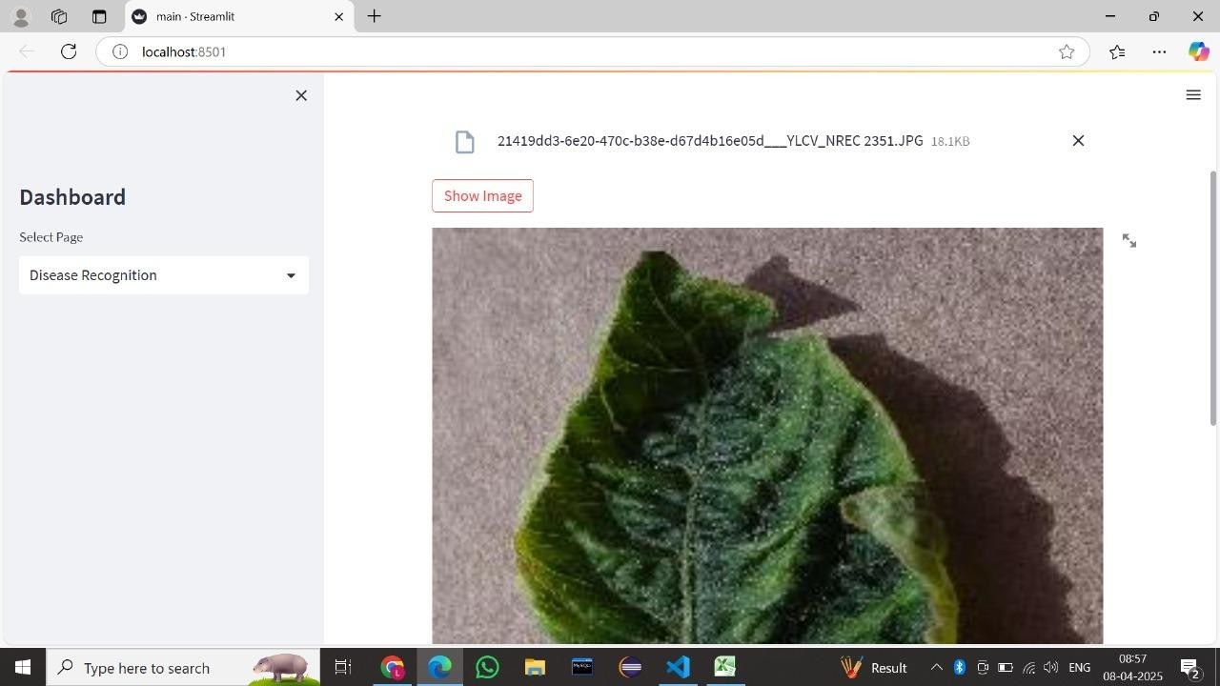

Fig: 11.5

Theoretical Workflow:

- Image Input:
User uploads a potentially diseased leaf image.

Image Display:
The app renders the uploaded image so the user can verify it.

Model Prediction:
On clicking "Predict," a machine learning model processes the image using a Convolutional Neural Network (CNN) or similar architecture.

Output:
The app classifies the disease (e.g., "YLCV" or "Healthy") and possibly gives confidence scores or suggestions.

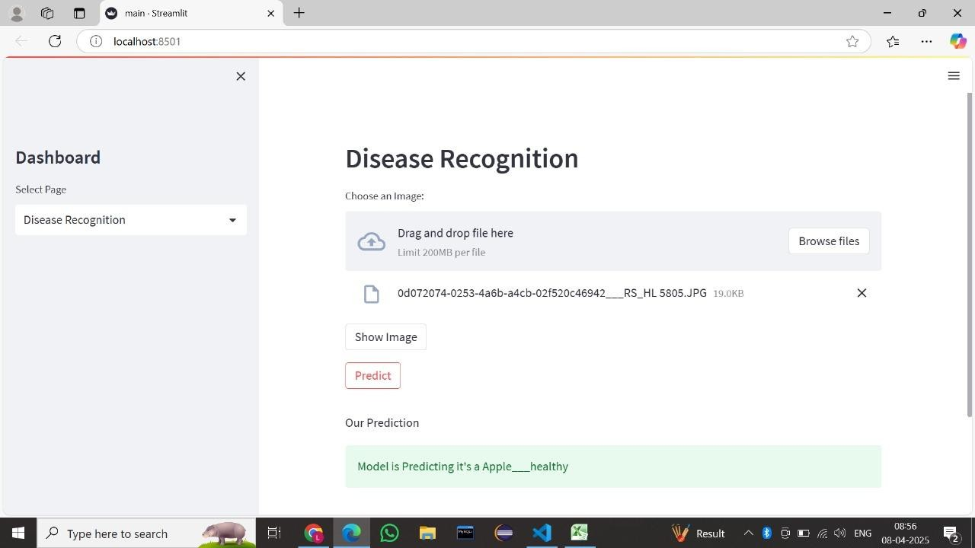

Fig:11.6

How the Model Works :
  - Preprocessing:
The image is resized, normalized, and prepared for the model.

  - Model Type:
A CNN (Convolutional Neural Network), such as ResNet, VGG, or a custom architecture.

  - Trained Dataset:
Likely trained on labeled leaf images from datasets like PlantVillage or a custom apple
disease dataset.

  - Output Classes:
Includes various disease types and healthy labels, e.g.:
    - Apple scab
    - Apple black_rot
    - Apple healthy

1. Image Upload:
  - The user selects an image of a leaf using drag-and-drop or file browsing.
2. Display Image:
  - Optionally, the image can be previewed using the “Show Image” button to verify
correct selection.
3. Prediction:
  - A trained machine learning model (likely CNN-based) processes the image and
classifies it.
  - Result displayed:
“Model is Predicting it’s an Apple healthy

CONCLUSION

In conclusion, the Plant Leaf Disease Detection project successfully achieved its objective of developing a deep learning-based system for automated identification of plant diseases. The system has been designed to help farmers identify plant diseases quickly and accurately, which in turn can lead to better crop management and improved yield. The project utilized various techniques and technologies such as image processing, machine learning, and deep learning to develop the system. The accuracy of the system was evaluated using a dataset of plant leaf images, and the results showed an overall accuracy of 99%, with some diseases having an accuracy of 98% .
The success of this project can be attributed to the use of appropriate tools, technologies, and methodologies throughout the development cycle. The project team used Jupyter Notebook for data preprocessing, training, and evaluation of the model. Python IDEs such as Visual Studio and IntelliJ IDEA were used for code development, while Fast API was used to deploy the model on a web server. The use of these tools and technologies ensured that the project was completed efficiently and effectively. Overall, the project demonstrated the potential of deep learning-based systems for automated identification of plant diseases, and the results obtained show that it can be an effective tool for farmers to improve crop management and yield.

FUTURE SCOPE

In the future, we plan to explore the use of more advanced machine learning models, such as deep neural networks, to further improve the accuracy of the plant leaf disease detection system. These models have demonstrated superior performance in complex classification tasks and could be fine-tuned specifically for agricultural applications by using more sophisticated architectures, including residual and attention-based networks. As computing power becomes more accessible through cloud services and affordable edge devices, the deployment of deeper and more powerful networks becomes increasingly feasible for real-world applications. Another area of future work could be to expand the dataset used to train the model, in order to increase its ability to detect a wider range of plant diseases and to better handle variations in environmental conditions.
We also plan to investigate the use of transfer learning, which would enable us to leverage pre-trained models to speed up the training process and improve overall accuracy. Transfer learning allows a model trained on a large, general dataset (such as ImageNet) to be fine-tuned on a smaller, domain-specific dataset, significantly reducing computational cost and training time. This approach is especially beneficial when labeled agricultural data is limited or expensive to obtain. In addition, we could explore the integration of additional sensors or data sources to further improve the system's ability to detect and diagnose plant diseases.
Finally, we could consider implementing a real-time monitoring and alert system, which would enable farmers to quickly identify and respond to potential plant diseases before they spread and cause significant damage to their crops.

These are just a few examples of what you could write in the "Future Work" section. The goal is to identify potential areas of improvement or expansion for the project, and to demonstrate your understanding of the potential impact of the system on the broader agricultural community.

REFERENCES

- Gaurav Verma, Charu Taluja, Abhishek Kumar Saxena “Vision Based Detection and Classification of Disease on Rice Crops Using Convolutional Neural Network” ,2019
- Nikhil Shah1, Sarika Jain2 “Detection of Disease in Cotton Leaf using Artificial Neural Network”,2019
- Ch. Usha Kumari “Leaf Disease Detection: Feature Extraction with K- means clustering and Classification with ANN”,2019
- S. D.M., Akhilesh, S. A. Kumar, R. M.G. and P. C., "Image based Plant Disease Detection in Pomegranate Plant for Bacterial Blight," 2019 International Conference on Communication and Signal Processing (ICCSP), 2019, pp. 0645-0649, doi: 10.1109/ICCSP.2019.8698007.
- H. Al-Hiary, S. Bani-Ahmad, M. Reya
- lat, M. Braik and Z. ALRahamneh “Fast and Accurate Detection and Classification of Plant Diseases”, 2011
- Kumar, M., Gupta, P., Madhav, P., & Sachin, “Disease Detection in Coffee Plants Using Convolutional Neural Network”,2020
- R. M. Haralick, K. Shanmugam and I. Dinstein, "Textural Features for Image Classification," in IEEE Transactions on Systems, Man, and Cybernetics, vol. SMC- 3, no. 6, pp. 610-621, Nov. 1973, doi: 10.1109/TSMC.1973.4309314.
- Francis, J. AntoSahayaDhas, & Anoop B K.,” Identification of leaf diseases in pepper plants using soft computing techniques.”,2016

